Mrs. Blouin / Iroquois Ridge High School
Name: ________________________________________________
TECHNOLOGICAL DESIGN

Bridge Assignment
Your goal is to create a bridge structure that can withstand the most weight suspended from it. The only materials you will be allowed to use are the supplied Popsicle sticks, and glue. You may use clamps, Xacto knives, and scissors to aid in the development of your bridge.
Part 1: RESEARCH
1. | Bridges are categorized into three primary types: suspension, beam, and arch.
2. | Each is designed and built according to certain principles of engineering.
3. | Find out what other students have created in bridge competitions.  http://www2.mohawkcollege.ca/events/popstick/popstickframeset.html

Part 2: Models
1. | Create a S.P.I.C.E model
2. | Create a perspective drawing (show VP) This is usually created after bridge design is completed.
3. | 1 full scale orthographic drawing (to be used for creation of the bridge)
4. | Create AutoCAD orthographic drawings. (top / side / front)

Part 3: Creation of the Bridge
1. | Students will be divided into groups of 2
2. | Rules:  1. Receive a bridge building kit  2. The building material shall only consist of the Popsicle sticks and Lepage's school glue supplied to you in the Bridge competition kit.  3. The bridge must not exceed the dimensions below:  4. The bridge weight must not exceed 250g  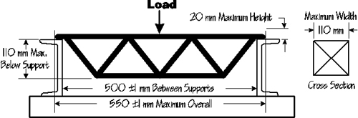
3. | One class period will be used to research bridge engineering.  Students should find out the basic principles of the three main kinds of bridges: suspension, beam, and arch.
4. | Each group will have another class period to brainstorm ideas, make sketches, and choose a final design for their bridges.
5. | Students will use a third class period to build their bridges with the materials provided.  After all bridges have been completed, students will test their bridges by seeing how many pennies they will hold. Students may modify their bridges, at this point, and then see if they will hold more pennies.
6. | Students will have a forth class period to take photos and create a PREZI presentation.
7. | Groups will present their bridges and testing results to the class.
8. | Students will answer the following:  Speculate about why some bridges were more or less successful than others.  What factors went into the strength or weakness of each bridge?  What flaws were inherent in the building materials?  How were those flaws overcome?

Part 4: PREZI or PPT (technical report)
1. | Your prezi or PPT will include the following information:  1. Situation (The Problem)  The situation sets the stage and informs the reader about what is being solved and why you are doing the report/project. It may state the identified needs and problems of the project at hand. Describe the problem with all relevant information available as guidelines and/or rules.  2. Research & Design description  The research is a gathering of all the information found on the product about to be built. The research should include as much information as possible on the history of the product, the use of the product, the physics involved in order to make this product work. You are allowed to use images as visual aid in your research, but copy pasting any article found on the Internet or any other means of resource will not be evaluated for marks.  The design description is an in-depth account of the process used in the design and fabrication of the product. The sentences in each paragraph should be kept short and to the point. It describes the route used to determine the solution to the design challenge. Include references to your research. Make sure your description is clear and precise, so that if need be someone else could build your article. Don’t just give a sequence of how you assembled the artifact.  3. Materials  List all the materials, sizes used in the fabrication of the final product. As much detail as possible should be given.  5. Drawings or Illustrations  Include all drawings or illustrations that were used in the development and fabrication of the project. This includes thumbnail sketches, rough sketches, technical drawings, illustrations, and/or photographs of models or products. Ensure all drawings are properly labeled and descriptive.  6. Conclusion  Describe what you learned in this design challenge. Include the results of testing solutions. Include a description on how each of the design criteria was met (or not). Why did it succeed? Why did it fail? Describe possible improvements or modifications for future work. Include what would you not do next time? Suggest other users or situations that may benefit from your research and/or testing.

Perspective Drawing
Here are a few examples of different angles for your drawing:

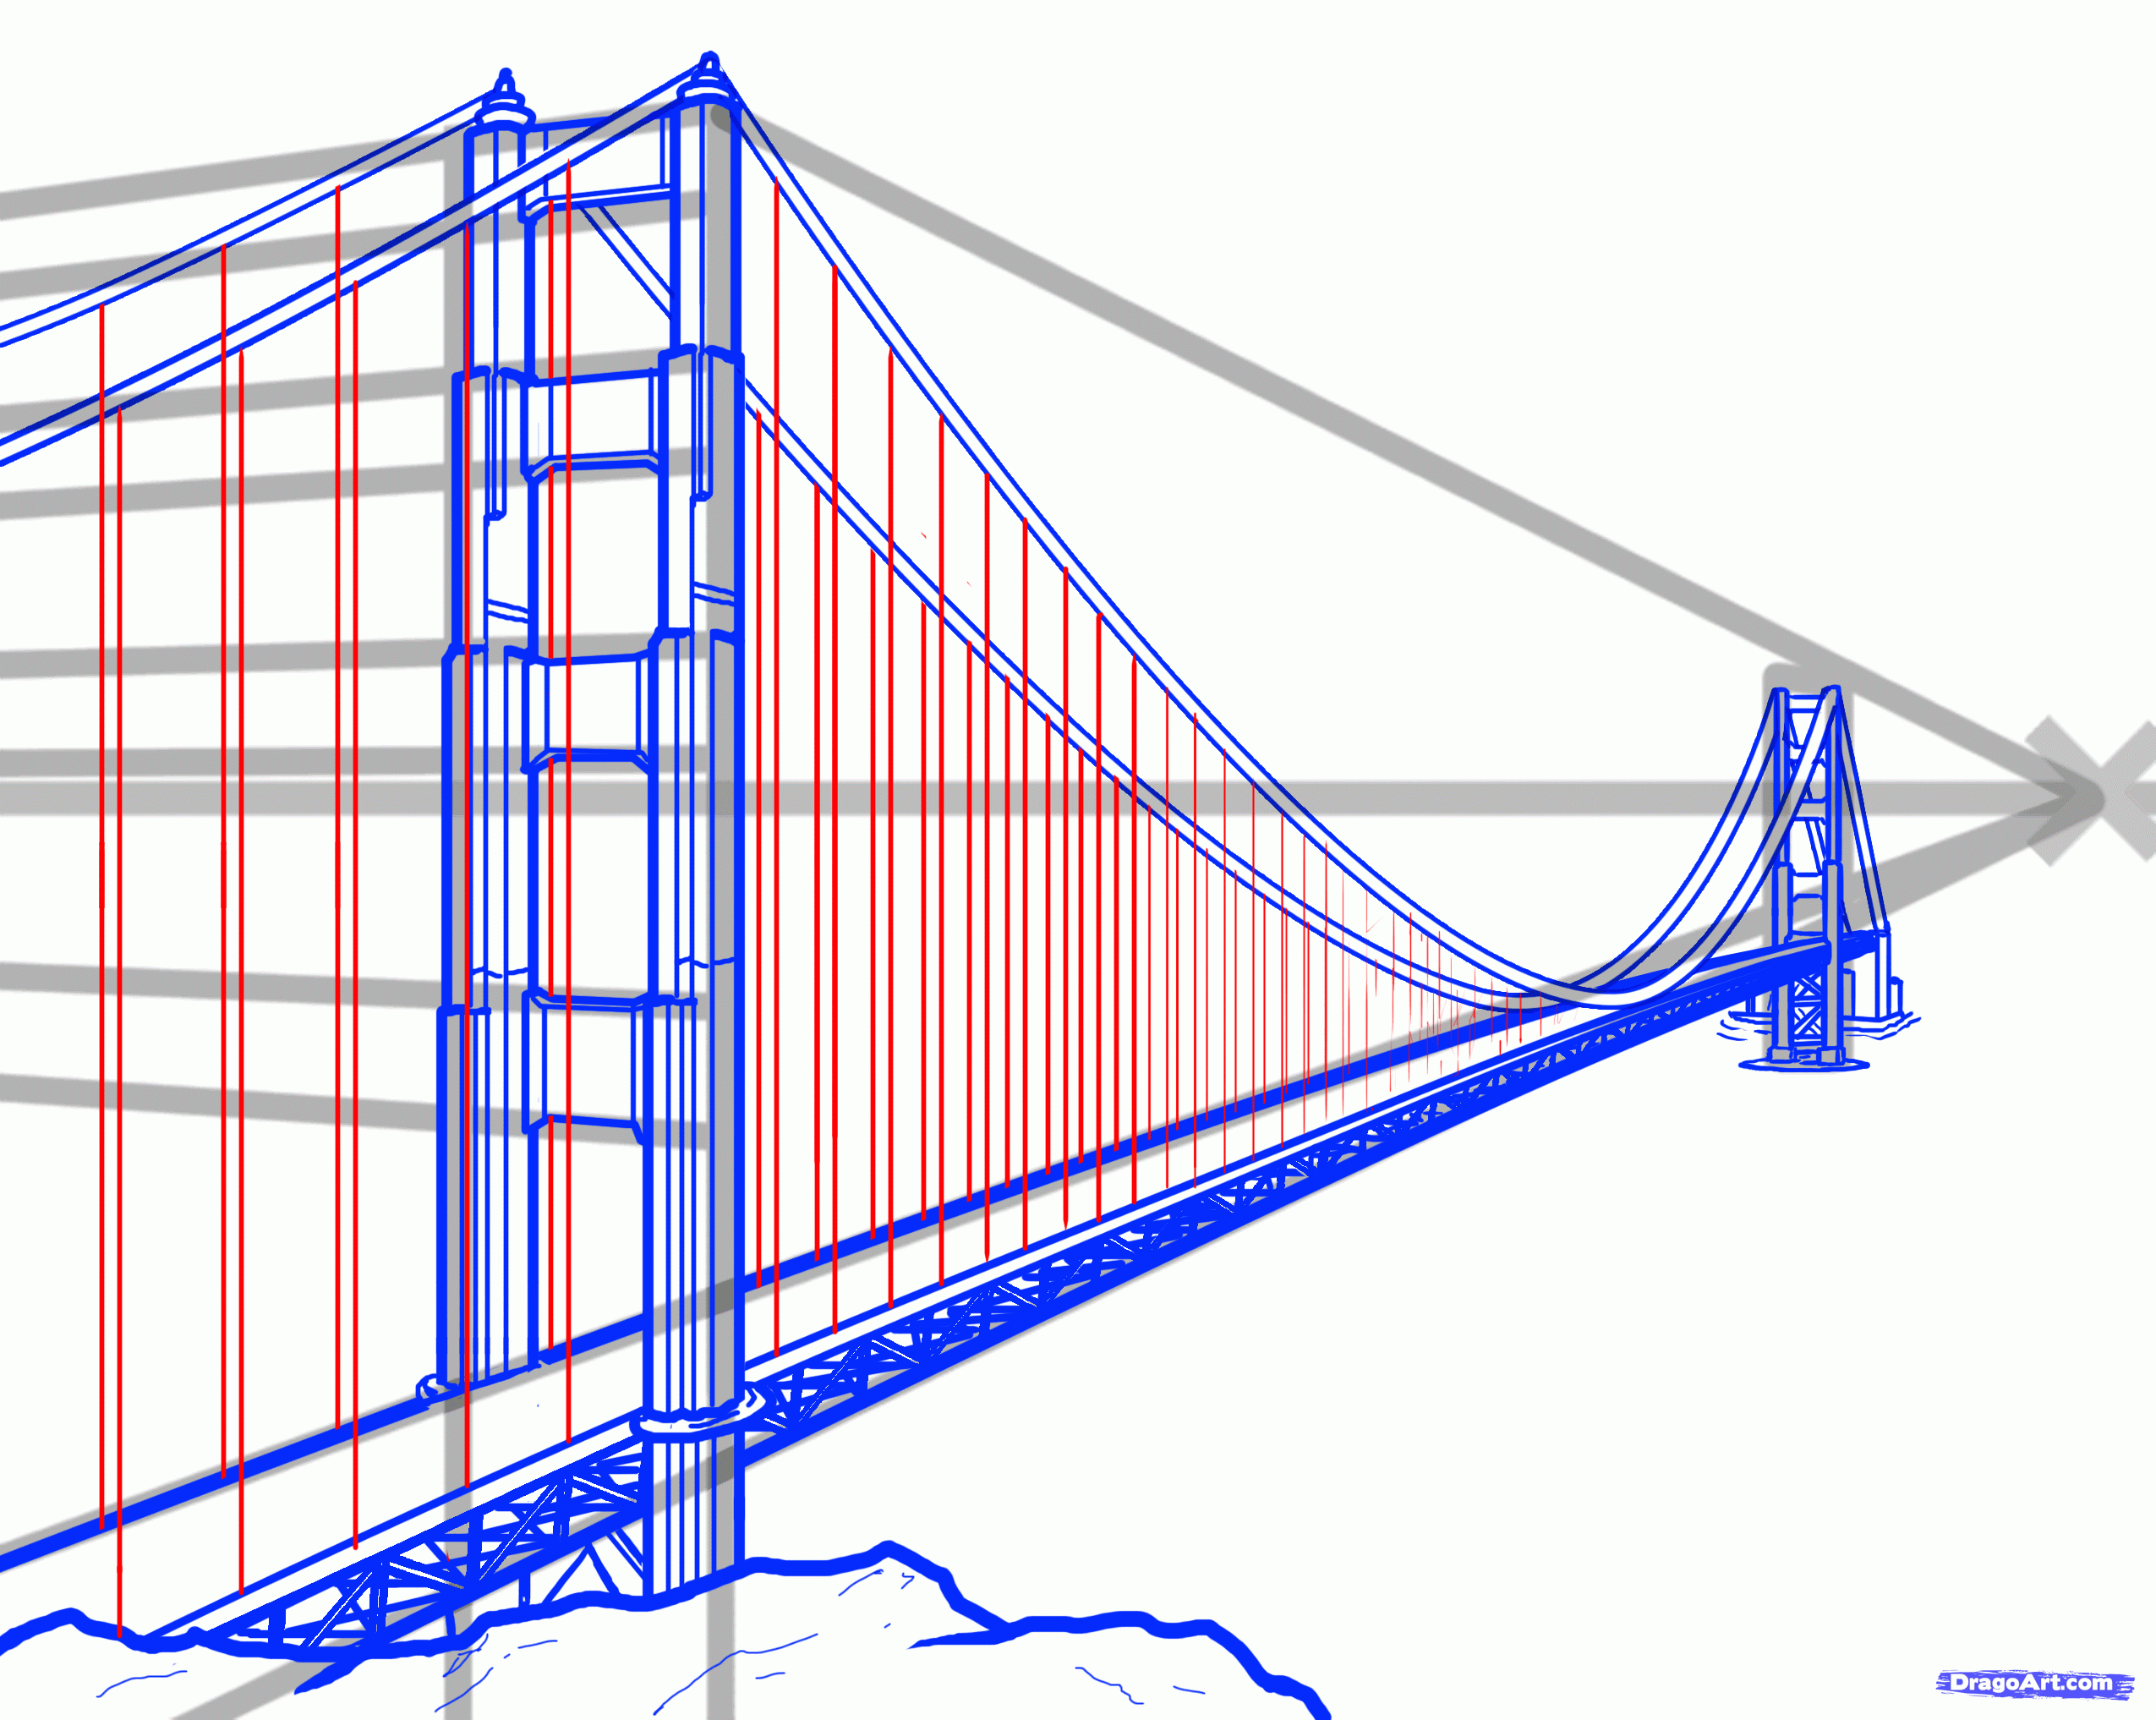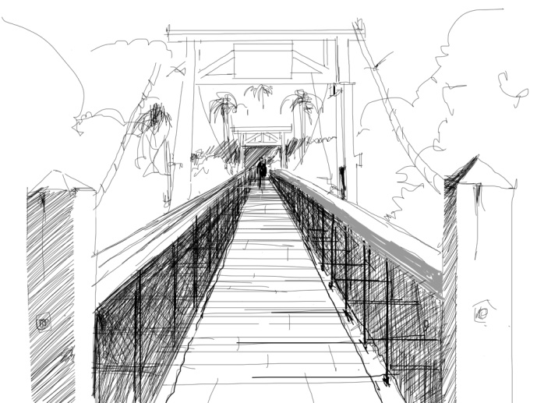
You will be evaluated as follows:
CATEGORY | LEVEL 1  12 13 | LEVEL 2  14 15 | LEVEL 3  16 17 | LEVEL 4  18 19 20
Research  (Knowledge) | Research is incomplete and missing valuable information. | Research is limited. | Research is informative and allows for development of proper structure. | Research is highly detailed. Descriptive informative allows for development of proper structure.
Full scale orthographic drawings  (Thinking) | All views are present and done with major issues. | All views are present and done with a few issues. | All views are present and done with minor issues. | All views are present and done to proper scale.
Perspective drawing  (Application) | Lines merge but with much room for improvement. | Lines generally at the VP. | Lines merge at the VP with few flaws in the drawing. | Lines merge seamlessly at the VP. There are no flaws in the drawing.
AutoCAD File  orthographic projections  (top / side / front)  (Application) | There are 1 or 2 missing views.  Generally the drawings can lead towards a final product, but there are flaws in which construction details may be very obscured. | All views are vaguely present.  Generally the drawings can lead towards a final product, but there are flaws in which construction details may be very obscured. | All views are present.  Generally the drawings can lead towards a final product, but there are flaws in which construction details may be obscured. | All views are present.  The drawings can lead towards a good final product. Details are clear and should produce a clear stable product.
Structure  (Application) | Structure was not created properly based on structural engineering principles. | Structure was somewhat created based on structural engineering principles. | Structure was created properly based on structural engineering principles. | Structure was created properly based on structural engineering principles and taken to an advanced level.
PREZI or PPT  (Comm.) | Only a few of the requirements have been met. | Many aspects present. However, some important components missing. | Generally all elements are present. | All elements are present.  Researches, SPICE, Sketches, AutoCAD, Photographs, Synopsis of project are all on the PREZI presentation.
Use of Time | Used time poorly (as shown by observation by teacher and/or documentation of progress in journal) in spite of several reminders to do so. | Used time well (as shown by observation by teacher and documentation of progress in journal), but required reminders on one or more occasions to do so. | Used time well during most class periods (as shown by observation by teacher, and documentation of progress in journal) with no reminders. | Used time well during each class period (as shown by observation by teacher, and documentation of progress in journal) with no reminders.

