Mrs. Blouin / Iroquois Ridge High School
Name: ________________________________________________
TECHNOLOGICAL DESIGN

Engineering Design Assignment
The design process takes days, weeks, sometimes even months or years, to complete and involves many different steps and phases along the way. If you recorded all of your work in different places, it would be almost impossible to find important thoughts when you need to refresh your memory. And, it would be difficult to gather all your work to present your final solution. To avoid being disorganized, designers and engineers keep design notebooks, where they record every detail of their projects along the way.
You will be required to submit a design book for this project. It will involved the following:
- Background research
- Interviews with users or experts
- CAD Drawings and sketches from all views
- Sketches or photos of the build process of prototype
- Lists of design requirements
- Photos of competing products
- Prototype
- Write Up on final analysis of design / questions/ issues you face

Background Research
Research on current trends and designs of your product concept. What can you do to make the design have a better function or form? Or if you have a new product idea that has not been developed, what items are similar? How will your product be different from what else is out there? Why is it an important new development? How will it work / function?
Interviews with users and experts
Spend some time interviewing users and experts who have used a current product similar to what you will design. Or interview someone who may have an opinion that could aid in your design process. Create a list of 10 important questions and ask a few individuals to get a non biased over view of opinions. You must come from an engineer’s perspective and not a industrial designer. Think more of science / functionality vs design.

Sketching and CAD Drawing from multiple views
or 3D CAD
Hand sketch and CAD sketch mechanical top / front / sides / and angle views of your design with dimensions. OR – draw your concept in a 3D design program of your choice.
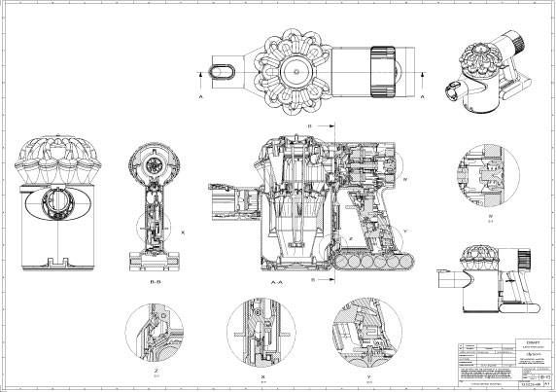
List of design requirements
List all items / materials you will need to create your prototype.
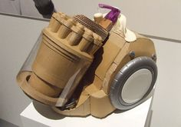
Prototype
Once you have come up with your concept you will create a prototype. A prototype is an operating version of a solution. Often a designer makes a prototype with different materials than the final version, and generally it is not as polished.

Prototypes are a key step in the development of a final solution, allowing the designer to test how the solution will work and even show the solution to users for feedback. Occasionally, designers will prototype pieces of the final solution very early in the design process. Sometimes designers will make several prototypes during the development of a solution.
Prototypes can help you to develop the structure, function, and appearance of your solution.
Cardboard, paper, poster board, mat board, and Foam-core are excellent modeling materials for prototypes. You can cut them easily with the proper knife, and you can assemble them with a variety of tapes and glues. You can find these materials at an art supply store. Plastic sheet and wood are also good modeling materials.

Found objects like plastic bottles, straws, aluminum cans, and other things lying around the house can often fill a need in your prototyping.
Create, test prototype, and make any alterations to help aid the design.
Photos or sketches during the process, and final result
Take photos of the development of your prototype and the final result.
Final analyses write up
Give a final write up of the successes, trials, and tribulations that you have had throughout the full process from all phases.

