Mrs. Blouin / Iroquois Ridge High School
Name: ________________________________________________
TECHNOLOGICAL DESIGN

Dream Home Design Project

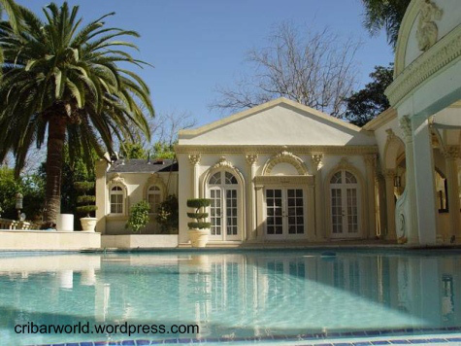

You have been given your high paying dream job and now have the chance to now live in your dream house. Being influenced from MTV Cribs, you will be able to come up with details for your dream home.
http://www.mtv.com/shows/cribs/series.jhtml

You will need to create a video presentation with a minimum of 15 slides describing in detail all aspects of your dream house. Each slide must be detailed by room and list all aspects of the room (ex. room colour, types of lighting, window treatments, furniture, wall colours, as well as - design elements, principles, and/or color schemes, etc).

You can add a video of yourself as the host describing details in your crib. You can create a short video as an introduction to each slide, or a promotional video at the end of the video presentation.

Make your project stand out! Add creative music, videos, etc.

Foundations of Interior Design
Dream House Presentations

Individually, students will create a Dream House presentation. This will be something carefully thought out, planned and organized, and creatively done. Students will present presentations to the class on ___________________.
The presentations should include the following:

Discuss the following in your presentation:
- Introduction Slide: name/picture/# of bedrooms and bathrooms
- Mini biography-who you are, where you will live, and what type of job you will have, how you made your money etc.
- An explanation for each room-description of furniture and/or style and why you chose that
Must include design elements, principles, and/or color schemes
- 15 rooms discussed (ex. Entrance, kitchen, dining room, living room, bathrooms, bedrooms, game rooms, pool room, movie room, laundry room.. etc.)
- Must have photos for each room and detail accessories (ex lights, lamp, rug, table, curtains etc)
- Landscaping

Presentation must also have a 2 minute video of you or someone you know willing to be the host. This can be either an into/exit video, or explanations during the presentation. See examples.

 | Level 1 | Level 2 | Level 3 | Level 4
Knowledge  The student demonstrates knowledge and understanding into interior design | The student is beginning to demonstrate knowledge and understanding of the history and production of interior design process and related Elements & Principles of Design. | The student demonstrates competent knowledge and understanding of the history and production of interior design process and related Elements & Principles of Design. | The student demonstrates good knowledge and understanding of the history and production of interior design process and related Elements & Principles of Design. | The student demonstrates exceptional knowledge and understanding of the history and production of interior design process and related Elements & Principles of Design.
Thinking  The student demonstrates thinking and inquiry into the process of interior design. | The student is beginning to demonstrate thinking and inquiry into the process of interior design by giving in-depth details and justification for using furniture/materials  /items listen in rooms. | The student demonstrates partially thinking and inquiry into the process of interior design by giving in-depth details and justification for using furniture/materials  /items listen in rooms. | The student demonstrates thoroughly thinking and inquiry into the process of interior design by giving in-depth details and justification for using furniture/materials  /items listen in rooms. | The student demonstrates innovative thinking and inquiry into the process of interior design by giving in-depth details and justification for using furniture/materials  /items listen in rooms.
Communication | Video is shot in incorrect vertical video format with improper camera techniques employed.  Video is less than 30 seconds. | Video is shot in incorrect vertical video format with partial proper camera techniques employed.  Video is less than 30 seconds - 1 minute. | Video is shot in correct horizontal video format and somewhat proper camera techniques employed.  Video is approx 1-2 minutes. | Video is shot in correct horizontal video format and proper camera techniques employed.  Video is min of 2 minutes.
Application  The student has applied their newfound knowledge of interior design design. | Powerpoint / Prezi / Video has been created with a low skill level.  Introduction Slide: name/picture/# of bedrooms and bathrooms is missing half of the information.  Mini biography is lacking details.  5-8 rooms have been discussed.  Landscaping has been discussed with vague details. | Powerpoint / Prezi / Video has been created with a moderate skill level.  Introduction Slide: name/picture/# of bedrooms and bathrooms is missing information.  Mini biography is somewhat descriptive.  8-11rooms have been discussed.  Landscaping has been discussed with some details. | Powerpoint / Prezi / Video has been created with a somewhat high skill level.  Introduction Slide: name/picture/# of bedrooms and bathrooms is somewhat complete and detailed.  Mini biography is descriptive.  12-15 rooms have been discussed.  Landscaping has been discussed with details. | Powerpoint / Prezi / Video is construction has been created with a high skill level.  Introduction Slide: name/picture/# of bedrooms and bathrooms is complete, detailed and accurate.  Mini biography is very descriptive.  15 rooms have been discussed.  Landscaping has been discussed with descriptive details.

