Mrs. Blouin / Iroquois Ridge High School
Name: ________________________________________________
TECHNOLOGICAL DESIGN
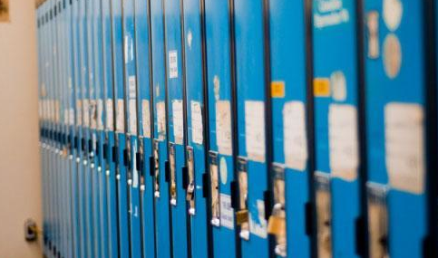
Assignment – Locker Wall Redesign

Lockers aren't designed for students today. In fact, the design of lockers hasn't changed since the days of your great grandparents!
But in the School of the Future things could be different. Re-imagine the design of a 21st century locker you would need as a Maker. A locker you could use to keep all of your stuff for making!

Let's get started on the challenge to redesign your school locker wall.

SPECIFICATIONS -
- Your locker wall will be 20'(length) x 6' (height) x 1’ (depth)
- Empty wall space above 2' (can be used for decorative, not usable)
- Wall must contain between 15-20 lockers
- Google SketchUp Locker wall will have 14-19 closed lockers and 1 open locker with all inside details.

How do you Collect Info for this step of the design process?

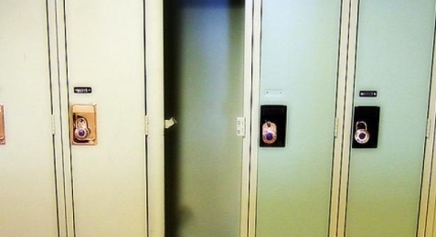
Gather more information about your existing school lockers by taking photos, sketching, conducting interviews, or doing additional research.
- How many times do you visit and open your locker each day? _______________________
What types of materials is your locker constructed from? ____________________________
Make a list of all the features your locker currently has. (Examples: hooks, air slots, etc.)
______________________________________________________________________________________________________________
Make a list of all the items you currently keep in your locker on a typical day.
______________________________________________________________________________________________________________
Next to each item, make notes about what 'needs' that item has. (Examples: my sweaty gym clothes need to kept away from my other things; my iPod needs electricity to be charged; my winter boots need a place to drip dry)
______________________________________________________________________________________________________________
Make a list of all the items you wish you could store in your locker, but don’t have room for.
______________________________________________________________________________________________________________

How do you Brainstorm Ideas for this step of the design process?

Make a list of all the things you like about your current locker. Ask several friends for their opinions.
______________________________________________________________________________________________________________
Make a list of all the things you dislike about your current locker. Ask several friends for their opinions.
______________________________________________________________________________________________________________
Based on the information you collected above, brainstorm a list of special features you’d like your NEW locker to have.
______________________________________________________________________________________________________________
______________________________________________________________________________________________________________
Make lots of sketches to get your early ideas down on paper.
Consider what materials the locker will be made from. What materials will be durable against the wear and tear of student use over the years?
______________________________________________________________________________________________________________

How do you create a Final 3D Google SketchUp Design for this step of the design process?
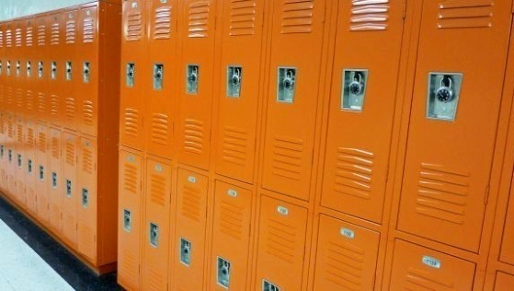
The final step of the design process is to create a more finished model that communicates your ideas to others.
What color or colors will your locker be? What colors have inspired you? Add colors to the digital model of your locker.
________________________________________________________________
What materials will your locker be made of? Choose materials and details to add to your digital model.
______________________________________________________________________________________________________________

* Include a human figure in your final locker model, so we can see how big your locker really is.

Congratulations on solving this design challenge!

You will be evaluated as follows:
CATEGORY | LEVEL 1  12 13 | LEVEL 2  14 15 | LEVEL 3  16 17 | LEVEL 4  18 19 20
CAD Sketch drawing  (Application) | Information displayed needs more detail. There are major flaws in the drawing. | Somewhat detailed information displayed. There are minor flaws in the drawing. | Detailed information displayed. There are minor flaws in the drawing. | Detailed information displayed. There are no flaws in the drawing.
CAD Sketch  (Knowledge) | Digital plan is incomplete or incorrect. Locker is missing many elements of a locker of the future. | Digital plan limited in creation and/or missing components. Locker is missing elements of a locker of the future. | Digital plan is detailed and dimensioned. There are no missing components. Locker is a good representation of a locker of the future. | Digital plan is highly detailed. All components are listed and dimensioned. Locker is a great representation of a locker of the future.
Research / Given During Presentation  (Knowledge) | Research is incomplete and missing valuable information.  Project details are limited. | Research is limited.  Project details are limited in descriptions. | Research is informative and allows for development of proper structure.  Project details are descriptive and relevant. | Research is highly detailed. Descriptive informative allows for development of proper structure.  Project details are very descriptive and relevant.
Presentation  (Comm.) | Student slouches and/or does not look at people during the presentation.  Student's volume is often too soft to be heard by all audience members. | Student sometimes stands up straight and establishes eye contact.  Student's volume is loud enough to be heard by all audience members at least 70% of the time. | Student stands up straight and establishes eye contact with everyone in the room during the presentation.  Student's volume is loud enough to be heard by all audience members at least 90% of the time. | Student stands up straight, looking relaxed and confident. Student establishes eye contact with everyone in the room during the presentation.  Student's volume is loud enough to be heard by all audience members throughout the presentation.
Use of Time  (Learning Skills) | Used time poorly (as shown by observation by teacher and/or documentation of progress in journal) in spite of several reminders to do so. | Used time well (as shown by observation by teacher and documentation of progress in journal), but required reminders on one or more occasions to do so. | Used time well during most class periods (as shown by observation by teacher, and documentation of progress in journal) with no reminders. | Used time well during each class period (as shown by observation by teacher, and documentation of progress in journal) with no reminders.

