Sketch Plan
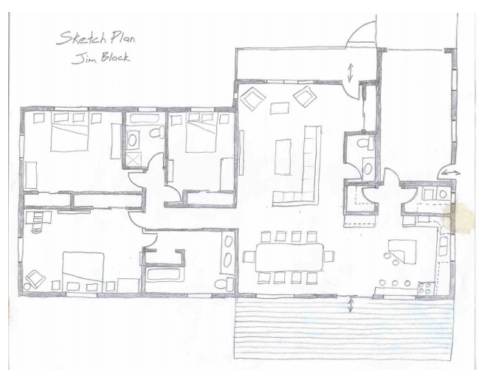
A sketch plan takes what has preceded it (the bubble and block diagrams), and forms the foundation (pardon the pun) for the house plan to follow. A sketch plan still doesn't include dimensions, though all wall/item dimensions should be relatively accurate so that the viewer can a firm idea of what the final house plan will look like. Door paths and relative wall thicknesses should be addressed and all interior features should be visible.
Remember - all exterior walls are typically 2x the thickness of interior walls for the purposes of the sketch plan (though in reality a 10" exterior wall is becoming the custom home standard....the 8" exterior wall is still the 'cardboard house standard').

