Mrs. Blouin / Iroquois Ridge High School
Name: ________________________________________________
TECHNOLOGICAL DESIGN

Emotion Sketch
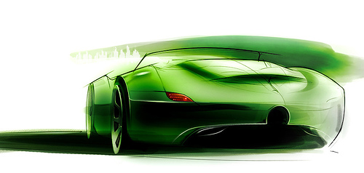
Source:Mikedesign
These are the sketches people go ga-ga over and a main source of a designer’s spine tingling sensation as well as frustration. Also called Inspirational sketches, such sketches are often use to set the tone of a design, brand language or product range.
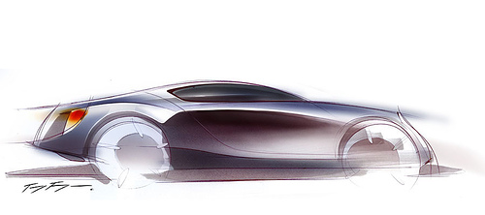
Source:Toyfon
Emotional sketches are also very difficult to do. Simply because an emotional sketch is extremely form orientated, and used as a means to communicate emotion. Hence the designers who create emotional or inspirational sketches are often called “form monsters” and have the uncanny ability to turn an emotion or expression keyword into a line, form or silhouette.
However one if you look closely into such sketching style you would realize such sketches don’t actually communicate a lot of information. If you look at the example above, can you ask yourself how does the door open? Where is the door handle? The side mirrors?
It’s because such sketches are meant to convey just the look or feel of a product and nothing more. It intentionally or unintentionally leaves out things like mechanical fixtures, part lines, or assembly information etc. The best emotional sketch designers are actually able to convert their sketches into great products, but unfortunately you be also surprised to know most cannot and remain in just form or concept development.
Information Sketch

The information sketch is perhaps the level at which what most designers, whom are worried about their sketching ability, should aspire to. It’s the minimum type of sketch level that would allow other designers to understand what you are trying to draw.
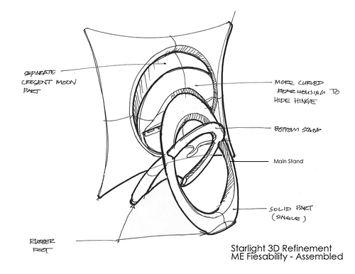

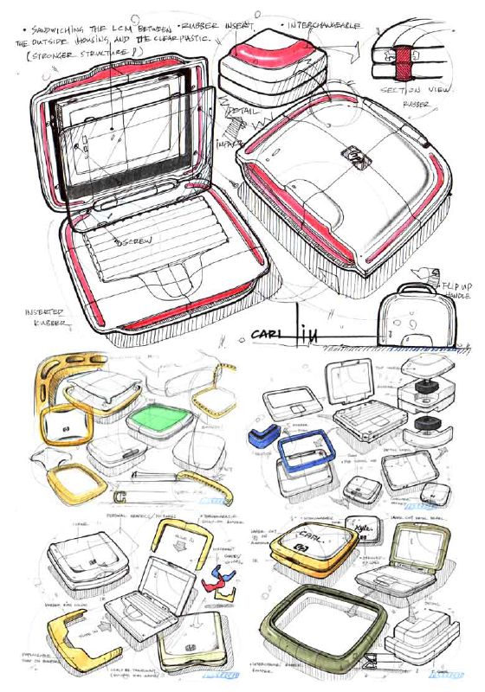
There are a lot of tangent lines, exploded views, transparent layering, a little color here and there, but all in all you can easily tell almost right away what is going on.

Right now so how do we do it?

How to we get to the level we are satisfied with?

Or how do we just improve our sketching ability?

