Mrs. Blouin / Iroquois Ridge High School
Name: ________________________________________________
TECHNOLOGICAL DESIGN

Redesign Your Classroom
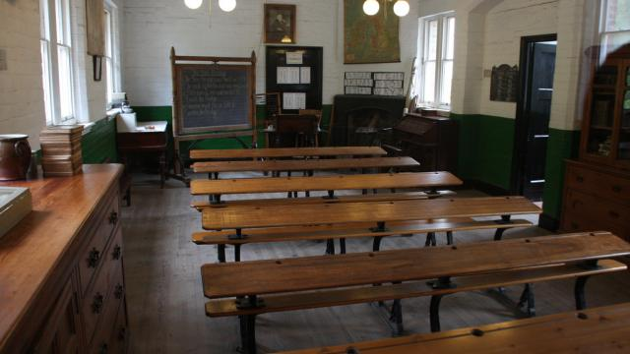

OBJECTIVE
Using the outline listed below for your research you will design a PREZI or PPT presentation that will include:
- All important information listed below
- Sketches (then either scan or take a photograph of your sketches)
- Google SketchUp mock-up design

What is a classroom? Is it that square, boring space where teachers and students spend much of lives between September and June? Most classrooms aren't designed for how students learn and teachers teach these days. In fact, the design of classrooms hasn't changed much since the days of your great grandparents!
But in the Classroom of the (Near) Future things could be different. Re-imagine the design of a 21st century classroom, but do not think your imagination has to go to 2050! What can you do tomorrow to make your classroom a futuristic model that speaks to our learning world today?
Let’s get started on the challenge to design a classroom of the (near) future.

Design Challenge Background
It is no secret that we all learn differently. And we also learn in different ways than our parents or grandparents did. What kind of physical space is needed to encourage new ways of thinking, synthesizing information, working amongst peers, and engaging with a world beyond the classroom's four walls?
Design Challenge Brief
Your challenge is to redesign your classroom and rethink how it should, or could, function as technology advances and our notion of study and sharing changes accordingly.

How does our use of technology shape the design of this space? (What technology is needed? What technology would be a great addition?)
____________________________________________________________________________________________________________________

____________________________________________________________________________________________________________________

____________________________________________________________________________________________________________________

____________________________________________________________________________________________________________________

Our guess is that your design won't feature rows of desks and teacher lecturing from a podium or a chalkboard!

Design Program / Parameters
You may redesign the interior of your existing classroom(s), expand on the existing space, or design a completely new addition on to your school building.
Your design should contain all the spaces and functions required for your general classroom needs – you could consider new ways of sitting (or even standing to work), as well as book and media storage (books are still cool to have around), space for the teacher (or maybe the teacher moves and the students stay).
You should also consider sustainability issues and the environmental impact of your design. (Example: Does your classroom of the future include a garden or energy lab?)
Will this classroom replace your existing classroom or become an addition to a different part of the building? Will it be built in an empty lot or space? Will it be underground or built on the roof? You decide.

IDEAS:
____________________________________________________________________________________________________________________

____________________________________________________________________________________________________________________

____________________________________________________________________________________________________________________

____________________________________________________________________________________________________________________

____________________________________________________________________________________________________________________

____________________________________________________________________________________________________________________

____________________________________________________________________________________________________________________

____________________________________________________________________________________________________________________
How do you Collect Info for this step
of the design process?
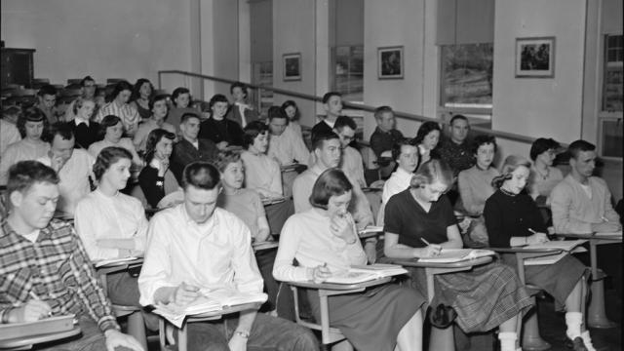
In the Collect Info step of the design process, you try to gather as much information as possible about your existing classroom and about your school.
Speak with the students and staff who will use it as well as other students, teachers, administration types, and people who help keep the school running. You can't propose new solutions until you figure out and document the existing problems!
The photos you take and the simple diagrams you sketch here will help you understand how the existing classroom location and design will compare with your new ideas.

Try This
- Walk around the interior of your classroom and school building and take photos. You can upload those photos to your Prezi / PowerPoint presentation. Be sure to write a detailed description for every image.
- Take interior photos of the hallways and entrances that lead into your classroom.
Interview several students, teachers, and other staff about what they think of their classrooms. What changes would they make to spaces if they had a choice?
____________________________________________________________________________________________________________________

____________________________________________________________________________________________________________________

____________________________________________________________________________________________________________________

____________________________________________________________________________________________________________________

Make a list of those features that you really like about how your classroom looks / functions.
____________________________________________________________________________________________________________________

____________________________________________________________________________________________________________________

____________________________________________________________________________________________________________________

____________________________________________________________________________________________________________________

Make separate list of all the ways that your current classroom is not so well designed (uncomfortable chairs, the light is poor, etc.)
____________________________________________________________________________________________________________________

____________________________________________________________________________________________________________________

____________________________________________________________________________________________________________________

____________________________________________________________________________________________________________________

Take measurements of the overall dimensions of your existing classroom.
____________________________________________________________________________________________________________________

____________________________________________________________________________________________________________________

____________________________________________________________________________________________________________________

____________________________________________________________________________________________________________________

Draw a floor plan of your existing classroom and include it in this step.

Use Google Maps to view and print out an aerial photo of your school. Cool, huh?

Think About
How many students are in your classroom during the day?
____________________________________________________________________________________________________________________

What types of furniture is used now? Does it need to be movable? Why or why not?
____________________________________________________________________________________________________________________

What is the artificial and natural light in the classroom like?
____________________________________________________________________________________________________________________

What materials are currently used on the floors, walls, and ceiling?
____________________________________________________________________________________________________________________

What are the different types of classrooms in your school? Are there any that are better or worse than yours?
____________________________________________________________________________________________________________________

ADDITIONAL RESEARCH:
____________________________________________________________________________________________________________________

____________________________________________________________________________________________________________________

____________________________________________________________________________________________________________________

____________________________________________________________________________________________________________________

____________________________________________________________________________________________________________________

____________________________________________________________________________________________________________________

____________________________________________________________________________________________________________________

____________________________________________________________________________________________________________________

____________________________________________________________________________________________________________________

____________________________________________________________________________________________________________________

____________________________________________________________________________________________________________________

____________________________________________________________________________________________________________________

____________________________________________________________________________________________________________________

____________________________________________________________________________________________________________________

How do you Brainstorm Ideas for this
step of the design process?
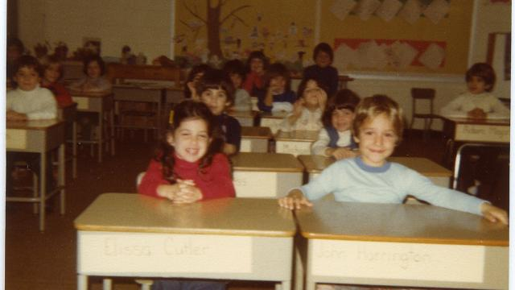

What inspires you?
In the Brainstorm Ideas step of the design process, you might gather some early big ideas of things that inspire you when thinking about a classroom of the future.

Try This
What kind of atmosphere supports creativity and innovation? How will you create these conditions in your lab? Find images on Flickr.com or google images that represent how you want the space to feel.
- Classrooms aren't the only places where learning takes place. Can you find other good examples on Flickr.com or google images of how they accommodate student and teacher needs?
- What kind of furniture and equipment will be in your new lab? Search on Flickr.com or google images for cool furniture, equipment, or technology that might work in your new classroom.
- Save copies of the images you find, and post them in the slides for your project. Include a hyperlink to the Flickr photo or google images in the caption, to credit the photographer
- Post images of buildings, colors, designs, textures, or other things that inspire you in this step. Make sure you give credit to your source!

How do you Develop Solutions for this
step of the design process?
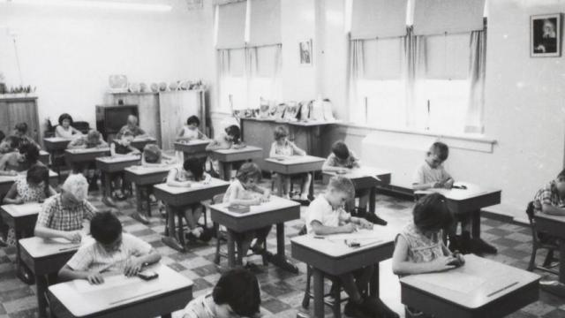
In the Develop Solutions step, your rough ideas come together with drawings or models that can show others your solutions for a new classroom.

Try This
- Draw a sketch or use software such as Google SketchUp to illustrate your ideas. You can upload photos (JPG files) and video files to your PREZI / Powerpoint presentation.
- Consider including the following types of spaces and furnishings:
- indoor seating and working area (tables, seating)
- outdoor seating area, if you decide to have one (tables, seating)
- book storage (shelves)
- media storage
- audio / visual lab corner or space
- integration of technology
- meeting / collaboration spaces
- home station for the teacher
- messy or wet area for building and crafts (just a thought)
- bins for recycling
How do you create a Final Design for this step of the design process?
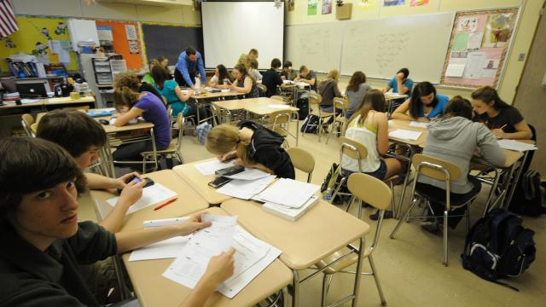
The final step of the design process is to create more finished drawings that illustrate your ideas to others. Remember, your explanation text, and the types of drawings, images, and models you share need to tell the whole story of your project to someone who may or may not have ever visited your school.

Good piece of advice: Your drawings and models should have enough information so that someone you've never met can see your project and understand what you are trying to say and how your design works. Pretty simple!

Try This in Google SketchUp
What color or colors will be in your classroom? What colors have inspired you? What kinds of floor, wall, and ceiling finishes would you like to use, and why?
____________________________________________________________________________________________________________________
____________________________________________________________________________________________________________________

Include some human figures in your final models and drawings, so we can see how big your space really is.

Upload additional images of your finished classroom design for your project portfolio. Write short captions explaining your ideas.
Congratulations on solving this design challenge!
PowerPoint or Prezi Presentation
Research
1. Include all of the research from the booklet. Add answers into the presentation.
2. Include any research you have done on other classrooms around the world and what you found interesting about them. Did they inspire your design?

Item Lists
1. Find an image for every item of your room from google or any online store. Ex (furniture, flooring, lighting, technology, wall colours etc.)
- Discuss why these items inspire your design (FORM – ex. Modern, contemporary, traditional design, etc. Think of what you learned during the interior design unit)
- Discuss why you choose each item (FUNCTION – ex. New technology creates an interactive class environment, or flow of traffic etc)
2. Discuss the different learning centers around your room.
- Why are these learning centers important?
- What kind of learning happens here? (ex. Individual, collaborative, creative, etc)

You will be evaluated as follows:
CATEGORY | LEVEL 1  12 13 | LEVEL 2  14 15 | LEVEL 3  16 17 | LEVEL 4  18 19 20
Research / Write Up  (Knowledge)  Questions from booklet are answered with google earth view of school and rough sketch ideas are put in a neatly organized booklet to hand in. | Research is incomplete and missing valuable information.  Project details are limited. | Research is limited.  Project details are limited in descriptions. | Research is informative and allows for development of proper structure.  Project details are descriptive and relevant. | Research is highly detailed. Descriptive informative allows for development of proper structure.  Project details are very descriptive and relevant.
Project Details  (Application) | Some aspects of the room have inspirational photos (item list), use of items have been discussed with some details of architecture and interior design principles. | Almost all aspects of the room have inspirational photos (item list), use of items have been discussed with some details of architecture and interior design principles. | Almost all aspects of the room have inspirational photos (item list), use of items have been discussed with details of architecture and interior design principles. | ALL aspects of the room have inspirational photos (item list), use of items have been discussed with exceptional details of architecture and interior design principles.
Hand Sketches drawing  (old classroom and new design)  (Application) | Information displayed needs more detail. There are minor to no flaws in the drawings. | Detailed information displayed. There are minor to no flaws in the drawings. | Somewhat detailed information displayed. There are minor flaws in the drawings. | Detailed information displayed. There are no flaws in the drawings.
Google SketchUp  (Knowledge)  (Application) | Digital plan is incomplete or incorrect. | Digital plan limited in creation and/or missing components. | Digital plan is detailed. There are no missing components. | Digital plan is highly detailed. All components are listed.
PREZI or PowerPoint  (Comm.) | Only a few of the requirements have been met. | Many present. Some important components missing. | Generally all elements are present. | All elements are present.  Researches, google view, Sketches, Photographs of current room, Items purchase list, Synopsis of project are all on the PREZI presentation.
Use of Time and Citizenship | Used time poorly in spite of several reminders to do so.  Respectful during all presentations. Spoke 3-4x and somewhat listened attentively.  Arrived to almost all presentations. Missed 3 days. | Used time well but required reminders on one or more occasions to do so.  Respectful during all presentations. Spoke 1-2x and somewhat listened attentively.  Arrived to almost all presentations. Missed 2 days. | Used time well during most class periods with no reminders.  Respectful during all presentations. Spoke once and listened attentively.  Arrived to almost all presentations. Missed 1 day. | Used time well during each class period with no reminders.  Respectful during all presentations. No talking and listening attentively.  Arrived to all presentations.

