Mrs. Blouin / Iroquois Ridge High School
Name: ________________________________________________
TECHNOLOGICAL DESIGN

Non-perspective drawing
Simply put non-perspective drawings have no perspective. That is to say, there are no vanishing points therefore lines that disappear into the distance have to be treated in one of two ways - a) they don't exist (an orthographic or elevation) or b) they exist, but no perspective will be applied to them (oblique and isometric view).
The following diagram is a sample of the typical reference material you might expect to receive on a technical illustration project. Most major plans after being designed will be broken down into elevation views (first 4 images) and an isometric form (last image at right) to be given to the people in charge of manufacturing the product.
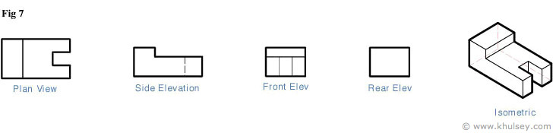
All objects of course are 3 dimensional and when displaying them in a 2D fashion we must include features not visible from the 2D viewer's angle (straight on in the case of an orthographic drawing, or from an edge-view from the case of a oblique or isometric view). Therefore, hidden lines must added to show that these features DO exist.
A simple breakdown of the non-perspective types of drawing can be seen below:

Orthographic / elevation view
Technically an Orthographic view is simply the 3 elevations combined into a page and spread so that the top, front and side views are positioned to easily convert them into an oblique or isometric view.
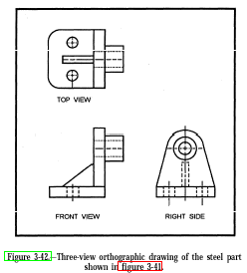

Oblique view
One face is flat, the angle of the Z axis is then 45 degrees off of this.
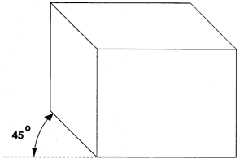

Isometric View
The front and Z axis are both 30 degrees to the horizon.
