Mrs. Blouin / Iroquois Ridge High School
Name: ________________________________________________
TECHNOLOGICAL DESIGN

Principles and Elements of Design Applied to Architecture PPT

Visual Design Elements

Six integral components used in the creation of a design:

1. ___________________________________
2. ___________________________________
3. ___________________________________

4. ___________________________________
5. ___________________________________
6. ___________________________________

Line

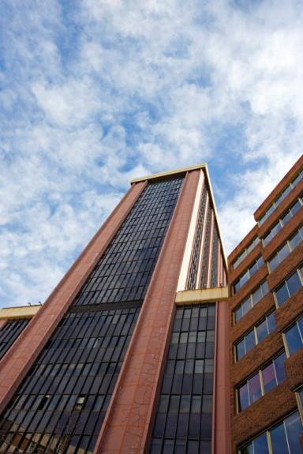

Types:

_______________________ Represents dignity, formality, stability, and strength
_______________________ Represents calm, peace, and relaxation
_______________________ Represents action, activity, excitement, and movement
_______________________ Represents freedom, the natural, having the appearance of softness, and creates a soothing feeling or mood
Colour

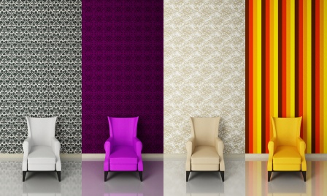

Color has an immediate and profound effect on a design.

_______________Colors
Reds, oranges, yellows

_______________Colors
Blues, purples, greens

Form and Shape

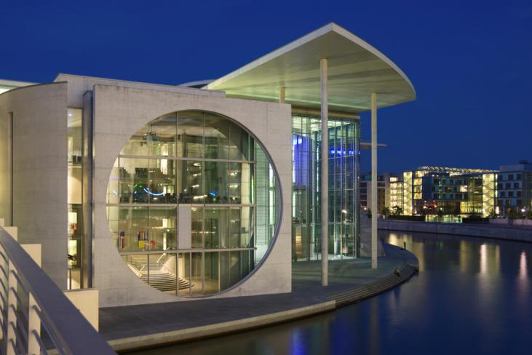

Form: (_______________) The shape and structure of something as distinguished from its substance or material.

Shape: (_______________) The two-dimensional contour that characterizes an object or area.

Shape

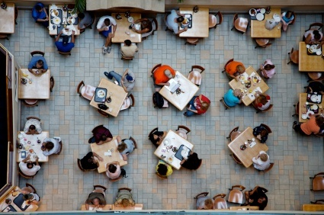

By incorporating the use of space in your design, you can _______________ or _______________the visual space.

Types

• _______________, uncluttered spaces
• _______________, busy spaces
• _______________ vs. good use of space

Texture

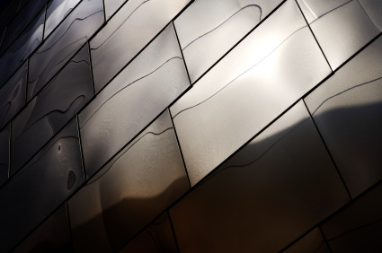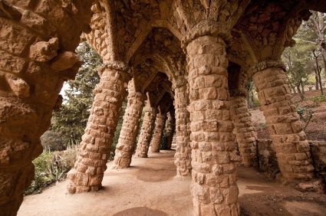

The surface _______________or _______________of something

_______________Surface – Reflects more light and therefore is a more intense color.
_______________Surface – Absorbs more light and therefore appears darker.

Value

The relative _______________or _______________of a color

Methods

_______________– Degree of darkness of a color
_______________– A pale or faint variation of a color

Visual Design Principles

Seven PRINCIPLES encompass an interesting design.

1. ______________________________
2. ______________________________
3. ______________________________
4. ______________________________
5. ______________________________
6. ______________________________
7. ______________________________

Balance

Parts of the design are ______________________________distributed to create a sense of stability. Both physical and visual balance exists.

Types

• ______________________________or formal balance
• ______________________________ or informal balance
• ______________________________ balance
• ______________________________ balance
• ______________________________ balance

Symmetrical or Formal Balance
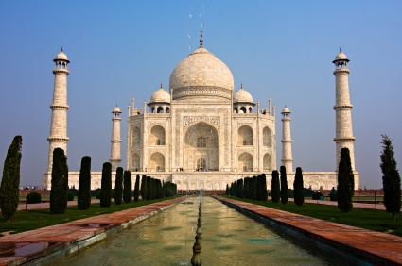
The elements within the design are ______________________________in relation to a centerline or axis.

Asymmetrical or Informal Balance

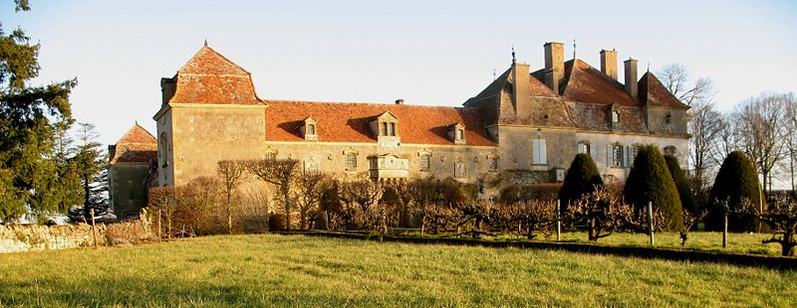

Parts of the design are ______________________________but are equal in visual weight.

Radial Balance

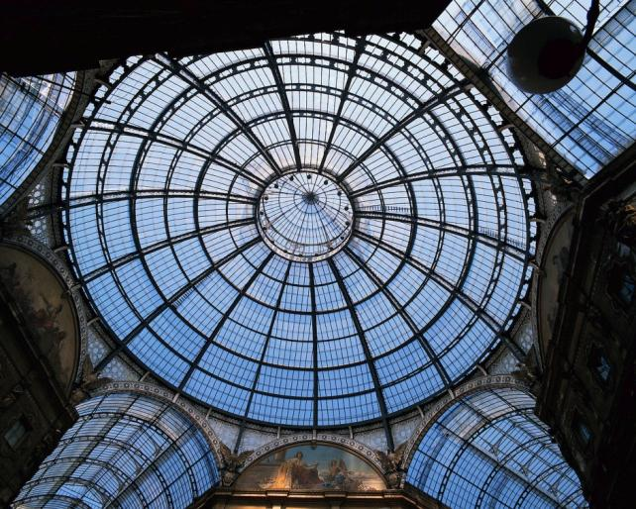

Design elements radiate ______________________________from the center.

Vertical Balance

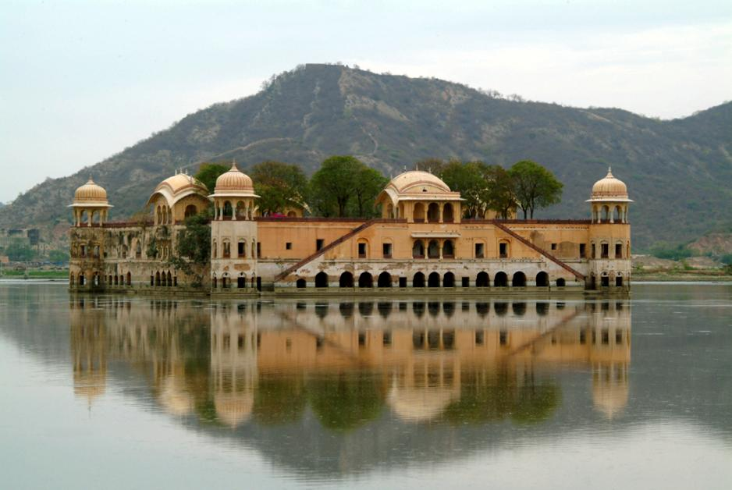

The ______________________________and ______________________________parts are equal.

Horizontal Balance

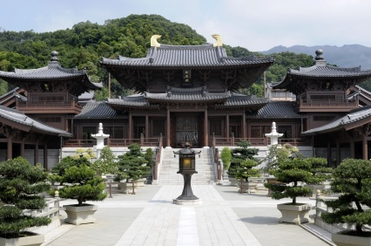

The parts on the ______________________________and ______________________________sides are equal.

Rhythm
Repeated use of line, shape, color, texture or pattern

Types

• ______________________________rhythm
• ______________________________rhythm
• ______________________________rhythm
• ______________________________rhythm

Regular Rhythm
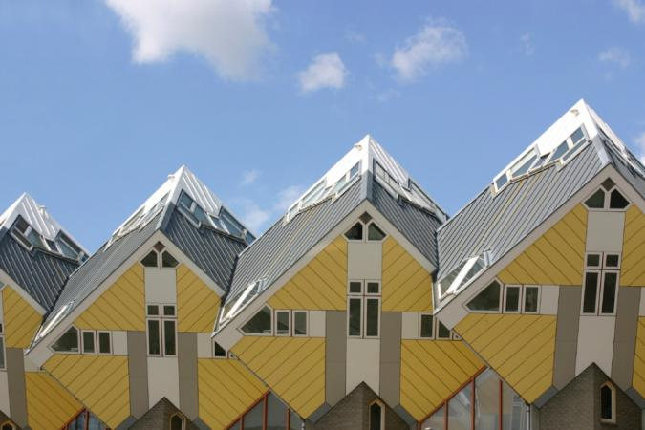
An element is repeated at the ______________________________repetition/interval each time.

Random Rhythm
The beats of the element are ______________________________or are at irregular intervals.

Gradated Rhythm
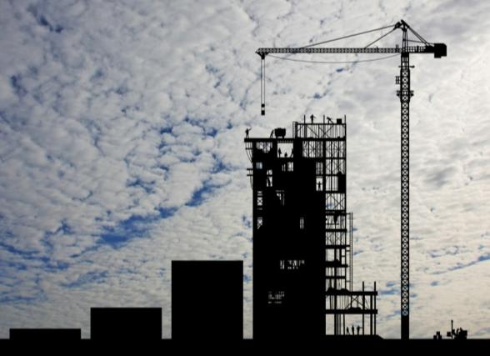
The repeated element is ______________________________with the exception of one detail increasing or decreasing gradually with each repetition.

Emphasis

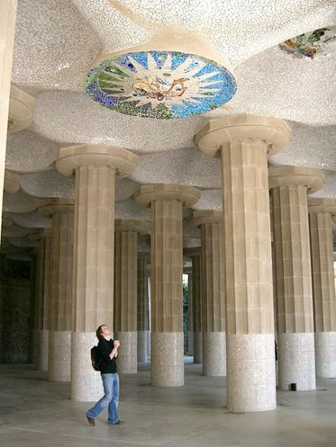

The feature in a design that attracts one’s eye – the ______________________________point

• Emphasis can be achieved through size, placement, shape, color, and/or use of lines

Proportion and Scale

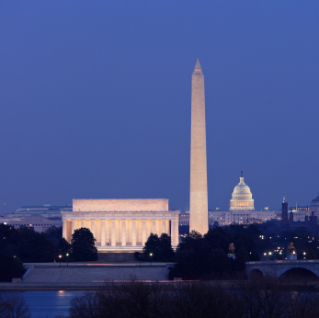

______________________________relationships between elements in a design with respect to size

3:5 ratio is known as the Golden Mean

Movement

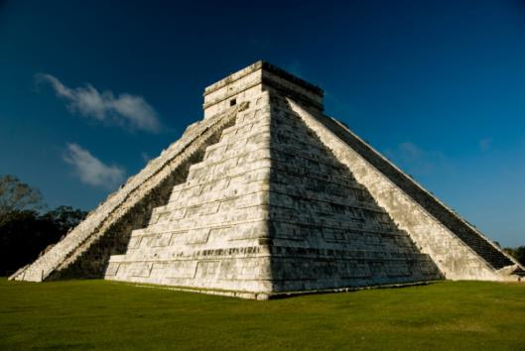

Flow or feeling of ______________________________

Contrast

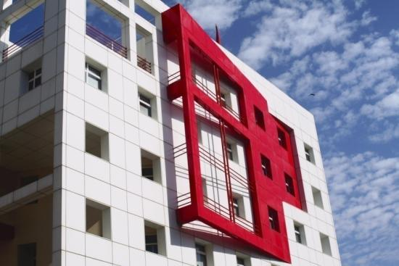

Noticeably different

Can be created with

• ______________________________
• Proportion and scale
• ______________________________
• Texture
• Etc.

Unity

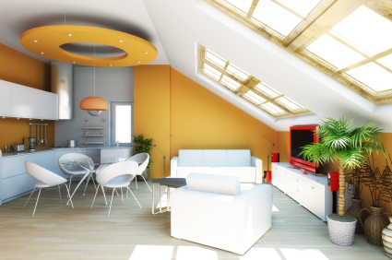

Unity is achieved by the ______________________________use of lines, color, material, and/or texture within a design.

