Interior Design Worksheet #5
Mrs. Blouin / Iroquois Ridge High School
Name: ________________________________________________
TECHNOLOGICAL DESIGN

- Complete a room layout using the room planner package provided.
- Label the architectural blueprint symbols.
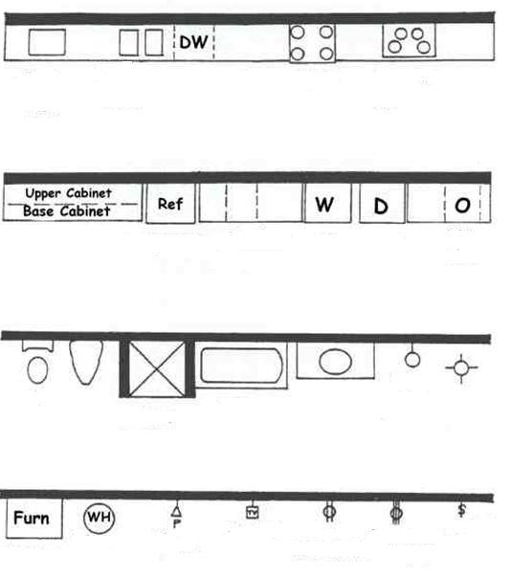

- Label the architecture symbols for a room.
