Block Diagram
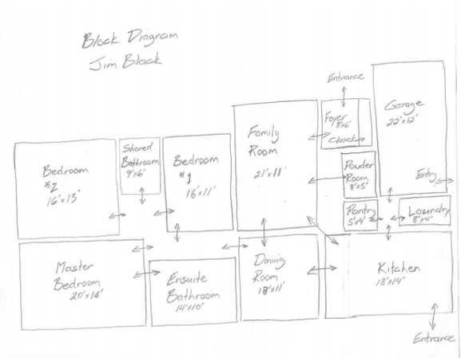
A block diagram is nothing more than a refinement of the bubble diagram. In the bubble diagram the intention is simply to outline the areas you want in a home, then show their interconnectedness. Positioning isn't critical in a bubble diagram.
Conversely - in a block diagram, positioning becomes important. Room sizes and relative locations are put down on paper. Interconnectedness is brought over from the bubble diagram.
The block diagram however still doesn't show furnishings, door positions (though roughly), or interior/exterior walls.

