Condo Design Project
Mrs. Blouin / Iroquois Ridge High School
Name: ________________________________________________
TECHNOLOGICAL DESIGN
The Problem:
Builders have been producing more and more condo units, as they can produce more units for sale on a smaller plot of land.

Condominium tall rise buildings are being built and marketed as a life style, where you will find many building benefits such as, Recreation rooms (gym, pool, sauna), conference rooms, coffee shops, small markets and some even offer movie theatres.
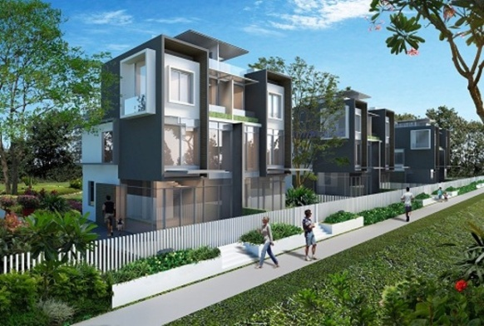
Some Condo’s are marketed as a Row house (town house) and benefits include gated community, pool and recreation building, attached golf course etc.

You may choose the style that you would like to create. You will need to show one unit fully detailed, every other unit you will show just the outer walls.

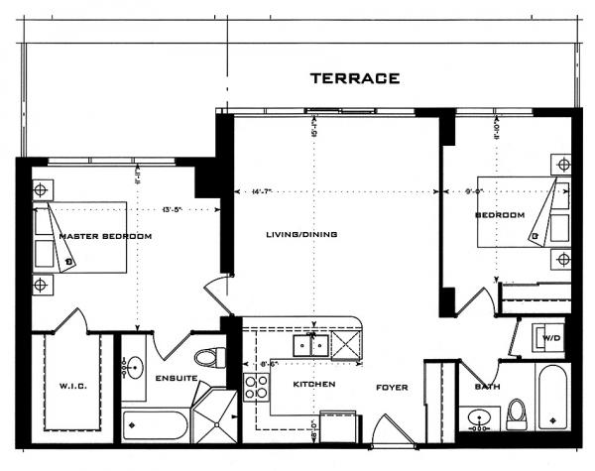
Requirements and Restrictions:
- One unit will be fully designed with 2-3 bedrooms, kitchen, dining, living, 2 bathrooms, laundry room/storage, and garage. (Garage may be a parking garage)
- A minimum of 10 condo units and a maximum of 50 units per building structure.
(You will need to show floor plans for each floor that is different from each other)
- Must have a min of 4 different floor plan /sizes of units.
(Ex. 600sq/ft, 850 sq/ft, 1000 sq/ft, 1250 sq/ft)
- Show appropriate hall ways or lane ways with fire exits.
- A minimum of three rooms per building ex. Coffee shop, storage, gym, pool, stores etc.
- A front detailed plan of how the building will look
(including entrance door, windows, pathway, and parking) (do not need to include landscape)

Assignment Requirements:
Technical Drawings
- Floor Plan for each of the 4 designs
(must have dimensions, Architectural Symbols : windows, doors, bathroom fixtures, kitchen appliances, etc)
- Floor Plan for each unique floor including hallway, elevator, fire exit.
- Site Plan showing building with parking facilities

CAD Drawings (your choice of software – AutoCad, floorstyler.com, Softplan, Google sketchUp)
- Floor Plan for each of the 4 unit
(must have dimensions, Architectural Symbols : windows, doors, bathroom fixtures, kitchen appliances, etc)
- Floor Plan for each unique floor including hallway, elevator, fire exit.
- Site Plan showing building with parking facilities

Examples of Architectural Symbols
(do more research to ensure you have all proper symbols in your design)
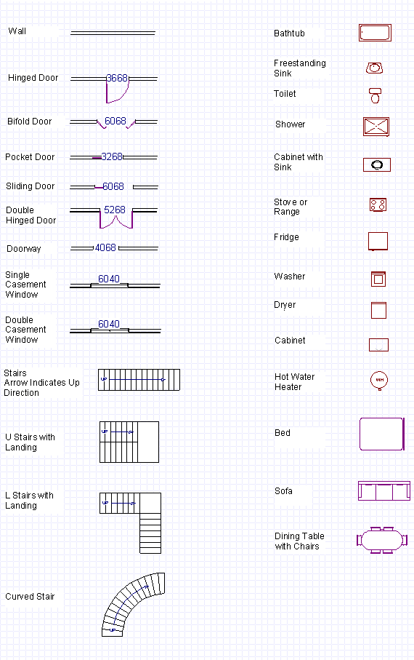

 | 4 | 3 | 2 | 1
Drawn Sketches
4 Rough Floor Plan Unit Sketches  Room Connections  Clarity/ Style  THINKING | Floor plans are very well organized and easy to read. Follows exact floor plan principles.  Floor plan is neat and is clearly labeled. | Floor plans are very well organized and easy to read. Follows most floor plan principles.  Floor plan is neatly or clearly labeled. | Floor plans are organized and easy to read. Follows some floor plan principles.  Floor plan is somewhat neat and labeled. | Floor plans are not organized and hard to read. Follows some floor plan principles.  Floor plan is not labeled and is poorly put together.
Final Floor Plans  Room Connections  Dimensions  All details  APPLICATION | Floor plans are very well organized and easy to read. Follows exact floor plan principles. | Floor plans are very well organized and easy to read. Follows most floor plan principles. | Floor plans are organized and easy to read. Follows some floor plan principles. | Floor plans are not organized and hard to read. Follows some floor plan principles.
Building Site Plan  APPLICATION | Sketches are very well organized and easy to read. Follows exact elevation sketch principles. | Sketches are very well organized and easy to read. Follows most elevation sketch principles. | Sketches are organized and easy to read. Follows some elevation sketch principles. | Sketches are not organized and hard to read. Follows some elevation sketch principles.

CAD
4 Floor plan units  (AutoCAD or Floorplanner.com)  meets code (wall thickness / openings), proper dimensioning, trim (doors/windows/block placement), room labels/area details, traffic flow / layout, block items of major furnishings present  APPLICATION | Floor plans are very well organized and easy to read. Follows exact floor plan principles. | Floor plans are very well organized and easy to read. Follows most floor plan principles. | Floor plans are very well organized and easy to read. Follows some floor plan principles. | Floor plans are not organized and easy to read. Follows some floor plan principles.  .
Final Floor Plans  Room Connections  Dimensions  All details  APPLICATION | Floor plans are very well organized and easy to read. Follows exact floor plan principles. | Floor plans are very well organized and easy to read. Follows most floor plan principles. | Floor plans are organized and easy to read. Follows some floor plan principles. | Floor plans are not organized and hard to read. Follows some floor plan principles.
Building Site Plan  APPLICATION | Sketches are very well organized and easy to read. Follows exact elevation sketch principles. | Sketches are very well organized and easy to read. Follows most elevation sketch principles. | Sketches are organized and easy to read. Follows some elevation sketch principles. | Sketches are not organized and hard to read. Follows some elevation sketch principles.
Final Floor Plans  Room Connections  Dimensions  All details  APPLICATION | Floor plans are very well organized and easy to read. Follows exact floor plan principles. | Floor plans are very well organized and easy to read. Follows most floor plan principles. | Floor plans are organized and easy to read. Follows some floor plan principles. | Floor plans are not organized and hard to read. Follows some floor plan principles.
KNOWLEDGE | Design concepts demonstrate a high level of knowledge. | Design concepts somewhat demonstrate a high level of knowledge | Design concepts demonstrate knowledge, yet lack some important factors. | Design concepts demonstrate knowledge, yet lacks some major important factors

PRESENTATION

COMMUNICATION
Voice, body, eye contact | Maintains eye contact with audience, voice loud enough for all to hear, stood still. | Maintain eye contact most of the time, voice was somewhat loud, some body movement. | Occasionally uses eye contact, frequently voice could not be heard, frequently body movement. | Little eye contact, seldom could not be heard, constant body movement.
Communication of Design | Communicates  design elements with ease and understanding of project. | Communicates  design elements  with understanding of project. | Communicates  design elements  with effort and basic understanding of project. | Communicates  design elements with basic /little  understanding of project.
Digital Presentation | Student’s PREZI, or PowerPoint presentation has all details from the project and is highly engaging. | Student’s PREZI, or PowerPoint presentation has all details from the project and is engaging. | Student’s PREZI, or PowerPoint presentation has most details from the project and is engaging. | Student’s PREZI, or PowerPoint presentation is missing details from the project and is somewhat engaging.

