Basic House types for residential architecture

For the purposes of our course there are 4 basic designs to choose from:
one-story ranch, 1 ½ story, 2 story and split-level.
TRY THIS: Calculate size necessary for 2400 sq.ft. ranch.
Compare that to 2 story house.

One Story Ranch:
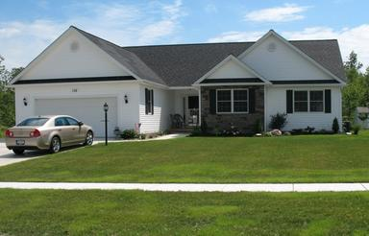
- It may have a basement depending on where in the country it is built, but may also sit on a crawl-space or slab floor.
- Chief advantage is that it lends itself to indoor/outdoor living (patios etc…)
- Absence of stairs (benefits/drawbacks)
- Low pitched roof and simple construction.
- Disadvantages:
- More expensive to build than other others with same square footage (more roof area).
- Heating more expensive for northern climate
- Larger lot

1 ½ story:
- Essentially a one-story ranch with a steeper roof so you get an attic space. Often called a "Cape Cod" the 1 1/2 story home was created to maximize living space yet have roof coverage over the 'walls' of the 2nd floor. In North America you get the 1950’s war-homes that are examples of these.
- Dormers are added to get light into the attic.
- Cost per unit is low.
- Heating costs are minimized due to outside wall area being relatively small (but hot attics in summer)
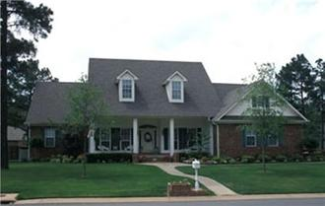
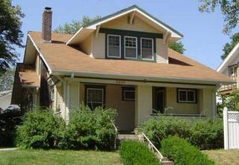
Disadvantages:
- Impinging ceiling on 2nd floor - any space under 5' in height is not considered to be living space.
- Not suitable for the elderly. Often 1 1/2 story homes have steep switchback stairs.
- If dormers are present, they increase the cost associated with roofing.

2 story house:
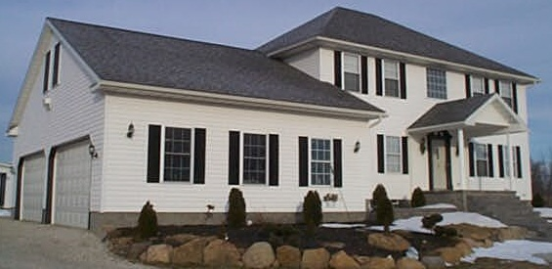
- Smaller lot requirement
- Heating and cooling relatively straightforward (heat rises) in the case of supplemental heating (wood stoves)
- Cooilng is fairly easy because the living space is not in the attic.
- sleeping space can often (usually) be separated from living spaces, or spaces of high traffic which increases privacy.
- you can maximize light entering all areas of space.
Disadvantages:
- Exterior maintenance is more costly.
- 2 stories means staircases.....which are a drawback for elderly or the infirm.
- basement is smaller than the equivalent area ranch home.
- laundry facilities are usually in the basement, which means that laundry must ascend/decent 2 flights of stairs.
- In the case of emergencies, you may have to exit a 2nd story to the ground.

Split level:
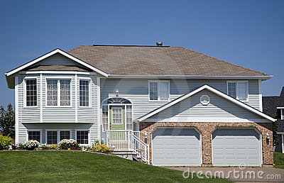
- Designs around sloped lots (but a bad idea if it’s a flat lot).
- Efficient use of space as the general arrangement requires little or no hall space.
- The basement footprint is about 40-60% of the overall space.
- The intermediate level (“ground level”) is where patios etc… tend to be.
- Variations (views of slope and elevation views of house)
Disadvantages:
- the living space and entry spaces are usually at different elevations which means constant lugging of goods/materials up short flights of stairs in the home
- even short flights of steps can be difficult for the elderly.
- difficult to heat

