Mrs. Blouin / Iroquois Ridge High School
Name: ________________________________________________
TECHNOLOGICAL DESIGN

Industrial Design Project – Personal Branded Skateboard Design

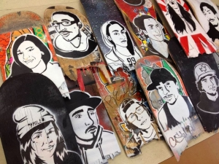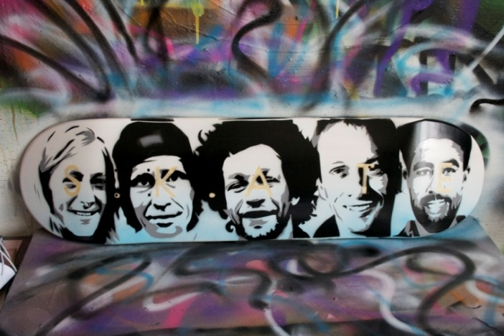

In this unit you will learn about industrial design and product creation.

Your mark will come from:
- The completion of Part 1 & 2 along with your first branded skateboard completely stencil painted and sealed.
- Industrial design sketches (multiple views) of board with graphic displayed
- The skateboard must be displayed at the Iroquois Ridge Art Show in January before being taken home to keep.

Part 1 – History of Skateboard Design
(must be typed and submitted)

Create a 1 page (single spaced, 12 pt) report on the history and production of skateboard graphics.
Must include:
- Discuss how the Elements & Principles of Design are necessary in the production of skateboard graphics.
Things to consider:
- How skateboards first came about and how they have expanded from there
- What different ways/ techniques have graphics been put onto skateboards
- How skateboards graphics started being designed on skateboards
- Famous skateboard graphic artists
- How skateboard branding has moved from just being printed on skateboards to other mediums

Part 2 - Worksheet – Artist’s Statement
(must be typed and submitted)

An artist statement is what, how, and why you do what you do, from your perspective. An artist statement builds another bridge between the artist and the audience. An effective statement creates a personal connection to the artwork and stimulates our human thirst for “story”. The artist statement is not just for art patrons and gallery owners. It is also for the artist. Writing an artist statement gives you another way to reflect on your work.

Answer the following questions in a 1-2 (single spaced, 12 pt) page document. Use #’s to reflect answers.

- Your Bio (hobbies, interests, how you see yourself as an artist)
- Describe the images for your design. Do you have a feeling or theme you are trying to convey?
- Your inspiration (sources, other artists/designers/photographers/companies/personal interests)
- Materials used and techniques (Your report should also include the skateboard stencil process related.)
- How you used the Elements and Principles of Design
- Personal response/feeling about your first skateboard design and what you have learned.
- Other thoughts…

 | Level 1 | Level 2 | Level 3 | Level 4
Knowledge  The student demonstrates knowledge and understanding into the history and process of skateboard design.  PART 1 | The student is beginning to demonstrate knowledge and understanding of the history and production of skateboard graphics, the skateboard stencil process and related Elements & Principles of Design. | The student demonstrates competent knowledge and understanding of the history and production of skateboard graphics, the skateboard stencil process and related Elements & Principles of Design. | The student demonstrates good knowledge and understanding of the history and production of skateboard graphics, the skateboard stencil process and related Elements & Principles of Design. | The student demonstrates exceptional knowledge and understanding of the history and production of skateboard graphics, the skateboard stencil process and related Elements & Principles of Design.
Thinking  The student demonstrates thinking and inquiry into the process of skateboard.  PART 2 | The student is beginning to demonstrate thinking and inquiry into the process of skateboard deck & graphic design by completing all steps of the process outlined in this package. | The student demonstrates partially thinking and inquiry into the process of skateboard deck & graphic design by completing all steps of the process outlined in this package. | The student demonstrates thoroughly thinking and inquiry into the process of skateboard deck & graphic design by completing all steps of the process outlined in this package. | The student demonstrates innovative thinking and inquiry into the process of skateboard deck & graphic design by completing all steps of the process outlined in this package.
Communication  The student uses their newfound knowledge and inquiry into skateboard design to communicate their branded skateboard.  PART 2 | The student’s branded skateboard is only beginning to be clearly communicated. Worksheet has not been communicated effectively and has missing elements. | The student’s branded skateboard is partially communicated. Worksheet has not been communicated effectively, more details are required. | The student’s branded skateboard is clearly communicated. Worksheet has somewhat been communicated effectively. | The student’s branded skateboard is creatively communicated. Worksheet has been communicated effectively.
Application  The student has applied their newfound knowledge of skateboard design.  BUILD & ART WORK | Sketch was created at a low skill level. Only 1 view displayed.  Skateboard construction has been created with a low skill level.  The student has minimally applied their knowledge of skateboard design to produce their branded skateboard completely stencil painted and sealed. | Sketch was created at a basic skill level. Only 1-2 views displayed.  Skateboard construction has been created with a moderate skill level.  The student has partially applied their knowledge of skateboard design to produce their branded skateboard completely stencil painted and sealed. | Sketch was created at moderate skill level. 2-3 views displayed.  Skateboard construction has been created with a somewhat high skill level.  The student has effectively applied their knowledge of skateboard design to produce their branded skateboard completely stencil painted and sealed. | Sketch was created at a high skill level. Over 3 views displayed.  Skateboard construction has been created with a high skill level.  The student has meaningfully applied their knowledge of skateboard design to produce their branded skateboard completely stencil painted and sealed.

