Mrs. Blouin / Iroquois Ridge High School
Name: ________________________________________________
TECHNOLOGICAL DESIGN

Eco Homelessness Research and Design
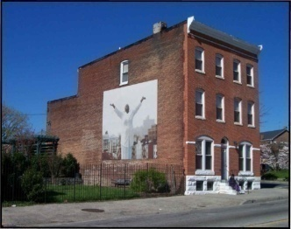
Using the Internet, do some basic research about homelessness. Answer the following questions and then brainstorm some creative solutions to alleviate the problem of homelessness. You will present your solutions to the class. Your solution must be in a digital format (PPT / Prezi / Video) to be displayed/played. You need to come up with a housing/community/social solution to this problem.
Research and Answer the following questions: (k)
- What is homelessness?
- Who is affected by homelessness?
- What other social problems are associated with homelessness?
- How do people become homeless?
- How does this affect society?
- What areas of the country are most affected by homelessness?
- What kinds of housing or public / community planning could be designed to help the homeless?
- What government programs/ housing are available for homeless people to live in?
- What do these housing units/ facilities look like?

Thoughts to help you create your solution. (t)
- What NEW community programs would prevent homelessness?
- What kinds of additional facilities and services could be designed to address this issue?
- Will your facility have a shelter area? Food preparation area? Food bank? Transitional housing units? Will it encompass any items that make it feel like a home? How can you make them feel comfortable (emotionally / physically)? Will it offer any development programs?
Your solution and presentation must contain the following information:
- Detailed answers to the questions posed above (k)
- Detailed list of all the eco friendly solutions.
- A photo/picture/diagram (can have images of possible property location, aspects of the building that you want to incorporate, structural factors, road/parking accessibility, room designs, etc.) (c)
- A drawn floor plan with room dimensions.
PLUS a Floor plan mockup (using any materials available ie. Cardboard, construction paper, foam core) Take a moment to research foam core architectural models to get an idea of a floor plan. Model not be larger than 24 inches x 24 inches (a)

Must:
- Be an eco friendly design.
- Be suitable for Canadian climate.
- Be either 2-6 floors.
- Be a reasonable size. 40,000 – 100,000 sq ft
- Lot max is 20,000 sq ft (must leave room for parking)

Creating Models

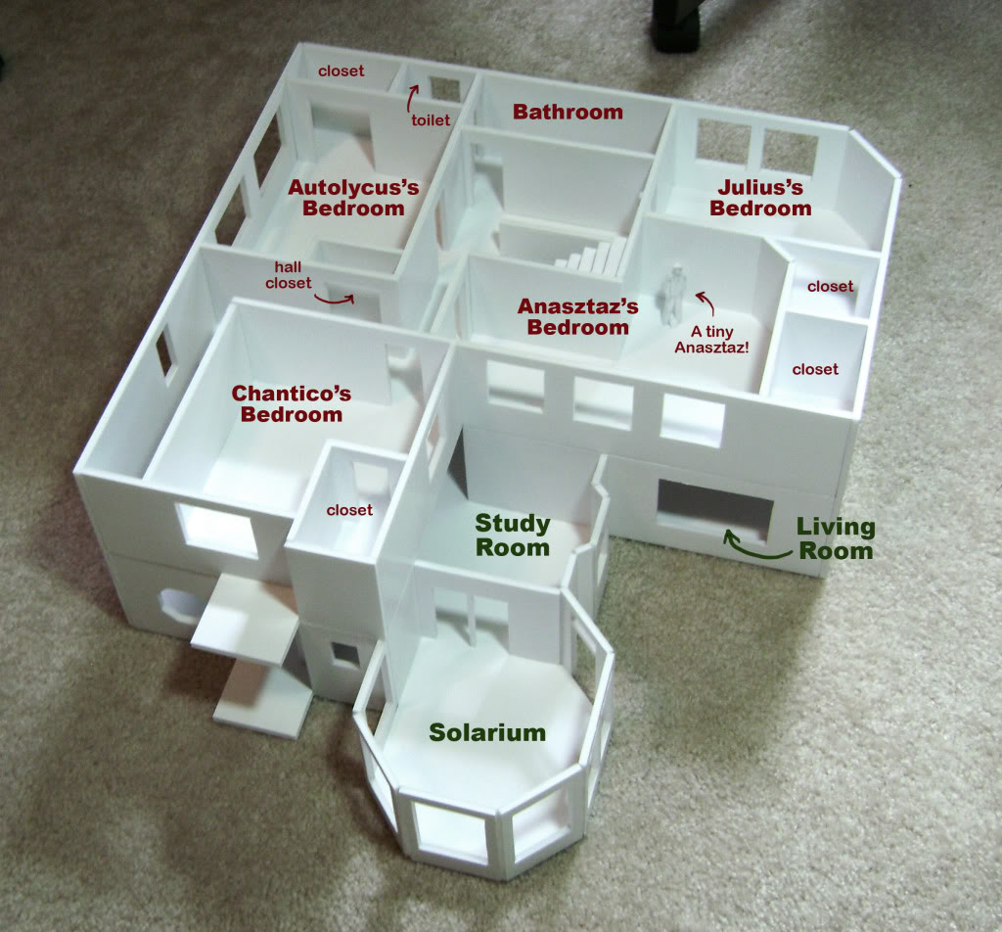

Depending on the type of model being built, model builders use foam board (foam-core), architectural cardboard (called illustration board), balsa or a softwood such as pine, spruce or basswood. It is crucial you have a SHARP Xacto knife (every 20 min. of cutting you should snap off the blade to use a fresh edge). Additionally, rubber glue and card-stock.
For your project you will use any materials that are available to you. You can use cardboard, construction paper, foam core, etc. You must use a material that is strong enough to stand up.

Homeless Shelter + Food Program
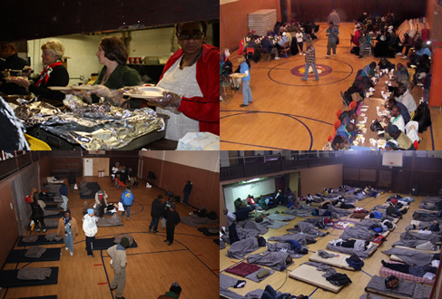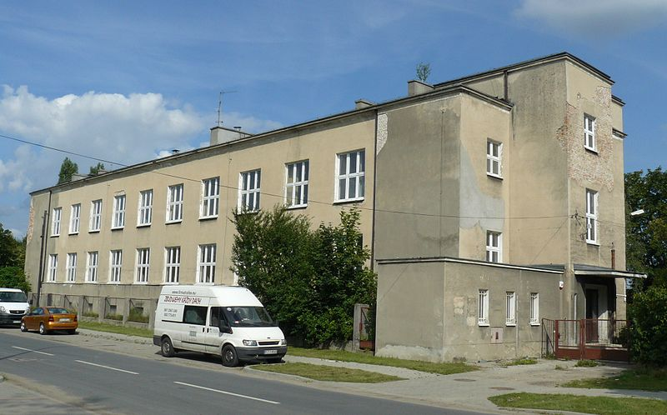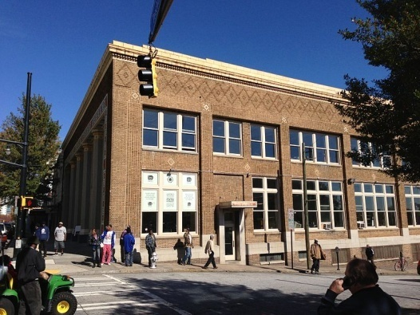
Transitional Housing
Individuals are offered the opportunity to live at the ministry's facility in private rooms or in dormitory settings.
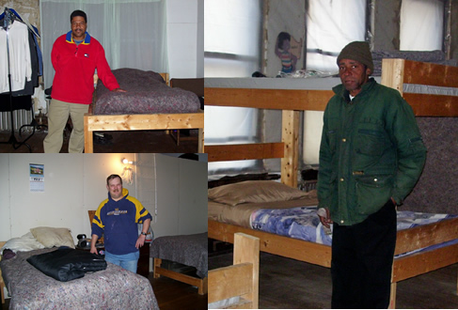
Rubric
 | Level 1 | Level 2 | Level 3 | Level 4
Knowledge | Research was vague or partially incomplete.  List of eco friendly features are well defined.  Building has 60 % eco friendly products.  Above 5 items. | Research was vague and needed more information.  List of eco friendly features are well defined.  Building has 70 % eco friendly products. Above 8 items. | Research was informative, yet needed more information.  List of eco friendly features are well defined.  Building has 80 % eco friendly products. Above 10 items. | Research was informative and educational.  List of eco friendly features are well defined.  Building has 90 % eco friendly products. Above 15 items.
Thinking | Project design is not effective for community living.  Project may incorporate facility features to aid in homelessness as yet does not incorporate transitional housing. (or vice versa) | Project design is somewhat effective for community living.  Project incorporates some facility features to aid in homelessness as well as transitional housing. | Project design is effective for community living.  Project incorporates facility features to aid in homelessness as well as transitional housing. | Project design is highly effective for community living.  Project incorporates many facility features to aid in homelessness as well as transitional housing.
Communication | Speaker did not have any visuals and came somewhat prepared. Presentation appeared to be incomplete.  Visuals did not clearly aid in explanation of model. | Speaker had visuals and came somewhat prepared. Presentation was somewhat interesting.  Visuals somewhat aided in explanation of model. | Speaker had many visuals and came prepared. Presentation was interesting.  Visuals aided in explanation of model. | Speaker had many visuals and came well prepared. Presentation was exciting.  Visuals defined and aided in explanation of model.
Application | Model was incomplete. | Model was complete, yet lacking information. | Model is complete, yet needs more information. | Model is complete and well thought out.

