Mrs. Blouin / Iroquois Ridge High School
Name: ________________________________________________
TECHNOLOGICAL DESIGN

Perspective Drawing For The Technical Illustrator

Perspective Basics
A thorough understanding of the principles of 1-Point and 2-Point Perspective is essential to creating an accurate, and visually appealing piece of art. A lay-person with no technical understanding of the principles of perspective drawing will nonetheless have an intuitive negative reaction to a piece of art in which something is amiss. Using the perspective techniques shown in the preceding tutorials, the mental impression they will make on a viewer will be so strong that once mastered, the illusion of 3-dimensional depth will remain, even when the visual trickery involved in the process has been revealed.
Any good technical illustration starts with well-executed line art. If you are working from any type of reference other than a CAD output in the desired angle, you will need to have a strong fundamental understanding of the principles of perspective drawing. This page will cover the various types of perspective angles you will encounter. In the tutorial lessons that follow this page, you will be given the tools needed to map out a perspective grid for any s-dimensional situation. From this grid, you will be able to create realistic three-dimensional drawings from flat or "Off Angle" reference.
The three photos below demonstrate the difference between 1-Point and 2-Point Perspective, as well as 3-Point Perspective. The first photograph (Fig. 1) is an example of one-point perspective. All of the major Vanishing Points for the buildings in the foreground of Fig. 1 converge at one central location on the horizon line. The angle of view or Point Of View (POV) in Fig. 1 is referred to as Normal View perspective. In Fig. 2 the vanishing points for the two opposing faces of the center foreground building project towards two different vanishing points on the horizon line. In Fig. 3 we see that the horizontal building elements project to the left and right horizon and the vertical building elements project to a central vanishing point in the sky. This upper vanishing point is called the Zenith. If one were looking down on the object from a Bird's Eye perspective, the vanishing point below the horizon and would be called the Nadir.
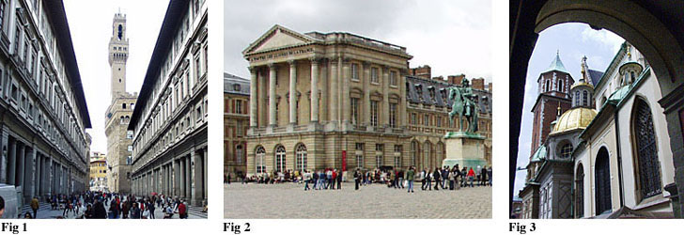

Deconstructing "Perspective" from Photography

In the next three diagrams, you will see the same three photographs with Vanishing Point trajectory lines (magenta) and Horizon Lines (blue) traced over the subject matter. Fig. 4 and Fig. 5 are both examples of Normal View perspective. A Normal View angle places the Horizon Line at a natural height as if the viewer was looking straightforward without tilting the head/camera up or down. In these two examples, you will notice that all of the vertical features of the buildings are straight up and down.
Fig. 6 is an example of a Worm's Eye perspective. In Fig. 6 the head/camera is tilted upward placing the Horizon below the picture. The perspective when the view is tilted in an upward direction creates a third vanishing point at the Zenith. All of the vertical building features will converge at this upper vanishing point. If we were looking down on a subject, the viewing angle would be a Bird's Eye View and the vertical details would converge at the Nadir.
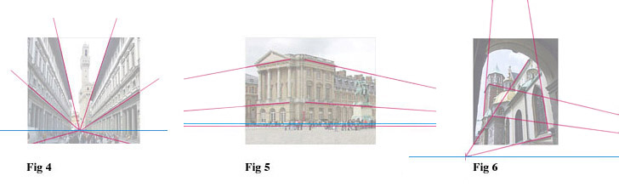
This technique of tracing parallel lines to their convergence point would be used to construct a Perspective Grid from exiting photographic material. Each convergence point will represent the exact location of the Horizon, Zenith, or Nadir in that photograph.

