Mrs. Blouin / Iroquois Ridge High School
Name: ________________________________________________
TECHNOLOGICAL DESIGN

Ecological School Addition
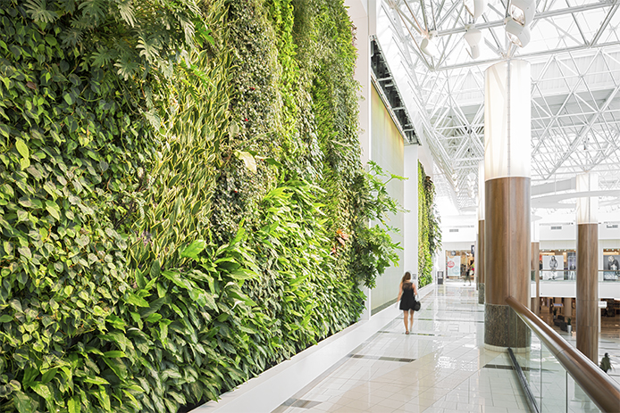Many schools were designed for the past and don’t reflect the 21st century learning environment. Some buildings need better ventilation or lighting, while others are simply not large enough to accommodate students comfortably. For this project, you are encouraged to envision an improvement for your school, something that would benefit everyone who uses it.
The most successful designs will be ones that identify a specific need and present a strong design ecological solution. The challenge is to add something that changes the footprint of your school building, while addressing a specifically identified need. Projects should include research and development, real world images and information showing why the need exists, in addition to final project design and information.
Use the following research to create your design brief. Min 2 page typed (single spaced, 12pt).

How do you Collect Info for this step of the design process?
Think About:
- What is the size of your school building? Using Google Earth and other online resources, generate a site plan for your school location.
- What are your initial thoughts about the building? For example, is your school lacking room for art classes? Physical education? Band practice space? Common areas? Cafeteria space?
- Talk to someone who has been at your school for a while, like a teacher or administrator. They will most likely have great insight as to what areas could stand to be improved.
- Search online for newly built schools and others that have been upgraded through similar processes. Do you notice anything in common among newly built schools?

How do you Brainstorm / Sketch Ideas for this step of the design process?
Identify the problem you want to solve based on the information you have collected.
Explore at least three possible solutions, each of which will no doubt help you as you search for the best addition to your school.
- What could your ideas look like?
- How would it change the landscape of your school?
- Who will benefit most from your design solution?
Try to answer these questions visually through sketching 3 different floor plan concepts, and in words.
How do you Develop Solutions for this step of the design process?
From the previous step, where you developed multiple solutions to the design problem, you should select one of your designs.
- What is your favourite design? Why?
- What aspects of your school would it improve?
- Who would benefit most from your new design?
- What materials would you be using, and why?
Ideally you will want to create plans of some kind to communicate your final vision, so start to sketch site plans, elevations, and even a final floor plan.
How do you develop a Final Design for this step of the design process?
Create a CAD version of your design with your chosen software. (floorplanner.com, floorstyler.com, AutoCad, Google SketchUp)
What you will need to hand in as well as add in your PPT / Prezi presentation
- Design Brief
- 3 rough floor plan design concepts
- 1 final floor plan design with all details (measurements, doors, windows, etc.)
- Elevation drawings
- CAD

 | 4 | 3 | 2 | 1
Design Brief  Rationale for design style (a paragraph or two with research ideas / pictures) for why you are building with that style in mind.  COMMUNICATION | Written component contains all required elements. | Written component contains most of the required elements. | Written component contains a few of the required elements. | Written component does not contain any of the required elements.
3 Rough Floor Plan Sketches  Room Connections  Clarity/ Style  THINKING | Floor plans are very well organized and easy to read. Follows exact floor plan principles. | Floor plans are very well organized and easy to read. Follows most floor plan principles. | Floor plans are organized and easy to read. Follows some floor plan principles. | Floor plans are not organized and hard to read. Follows some floor plan principles.
Final Floor Plan  Room Connections  Dimensions  All details  APPLICATION | Floor plan is very well organized and easy to read. Follows exact floor plan principles. | Floor plan is very well organized and easy to read. Follows most floor plan principles. | Floor plan is organized and easy to read. Follows some floor plan principles. | Floor plan is not organized and hard to read. Follows some floor plan principles.
Elevation Sketches (4)  APPLICATION | Sketches are very well organized and easy to read. Follows exact elevation sketch principles. | Sketches are very well organized and easy to read. Follows most elevation sketch principles. | Sketches are organized and easy to read. Follows some elevation sketch principles. | Sketches are not organized and hard to read. Follows some elevation sketch principles.

Floor plan (AutoCAD or Floorplanner.com)  meets code (wall thickness / openings), proper dimensioning, trim (doors/windows/block placement), room labels/area details, traffic flow / layout, block items of major furnishings present  APPLICATION | Floor plan is very well organized and easy to read. Follows exact floor plan principles.  Floor plan is neat and is clearly labeled. | Floor plan is very well organized and easy to read. Follows most floor plan principles.  Floor plan is neatly or clearly labeled. | Floor plan is very well organized and easy to read. Follows some floor plan principles.  Floor plan is somewhat neat and labeled. | Floor plan is not organized and easy to read. Follows some floor plan principles.  Floor plan is not labeled and is poorly put together.  .
KNOWLEDGE | Design concept demonstrates a high level of knowledge. | Design concept somewhat demonstrates a high level of knowledge | Design concept demonstrates knowledge, yet lacks some important factors. | Design concept demonstrates knowledge, yet lacks some major important factors
THINKING | Design concept utilizes majority of eco-friendly features. List is complete and accurate. | Design concept utilizes some of eco-friendly features. List is complete and somewhat detailed. | Design concept utilizes a limited of eco-friendly features. List is complete and lacks some details. | Design concept utilizes only a couple of eco-friendly features. List is missing details.

PRESENTATION

COMMUNICATION
Voice, body, eye contact | Maintains eye contact with audience, voice loud enough for all to hear, stood still. | Maintain eye contact most of the time, voice was somewhat loud, some body movement. | Occasionally uses eye contact, frequently voice could not be heard, frequently body movement. | Little eye contact, seldom could not be heard, constant body movement.
Communication of Design | Communicates  design elements with ease and understanding of project. | Communicates  design elements  with understanding of project. | Communicates  design elements  with effort and basic understanding of project. | Communicates  design elements with basic /little  understanding of project.
Digital Presentation | Student’s PREZI, or PowerPoint presentation has all details from the project and is highly engaging. | Student’s PREZI, or PowerPoint presentation has all details from the project and is engaging. | Student’s PREZI, or PowerPoint presentation has most details from the project and is engaging. | Student’s PREZI, or PowerPoint presentation is missing details from the project and is somewhat engaging.

