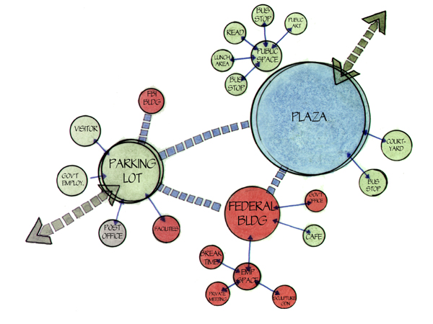
Start Here
The big question is where do you start in an architectural design? First off, you think of who it is for. Next ask yourself what does it need to accomplish. Finally, you look at how you're going to get there. To that end, start your plan with a bubble diagram.

Bubble Diagrams
Bubble diagrams are free flowing concepts to help you start-getting ideas for your design. You can represent ALL aspects of a design with a bubble diagram from the site plan, to the building itself.
Begin by taking your base floor plan and laying your tracing paper over the top of it. Keep your site programming and any notes and photographs you’ve taken handy as you may want to reference them throughout the process.
To start designing you begin with a “bubble diagram”. This bubble diagram defines spaces within the base plan. Later on, these spaces will be further developed to include specific rooms, circulation, and designated spaces. Start by sketching various shapes and sizes of bubbles. These bubbles represent areas within the base plan. But by using this freehand type drawing you are free to be creative and not confined to any specific elements. This is the time to have fun with the design process.
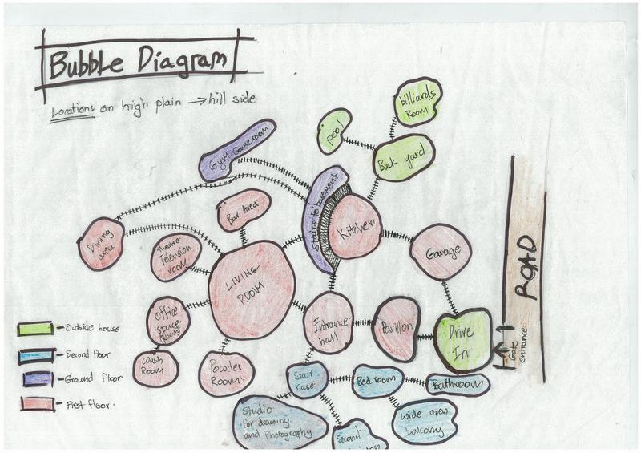
Bubbles can represent different areas, and any other amenities you would like to have in your building. This diagram will provide a general organizational structure for a design. It is similar in effect to what an outline is for a written report. Remember, you are not concerned about specifics at this time, but rather overall design concepts. This is a creative function; don’t over think the process; just put your pencil to paper and start drawing circles, ovals, etc. and get some ideas flowing.
These diagrams are very critical to the overall design process. The reasoning behind doing several bubble diagrams is that they encourage you as a designer to explore various design solutions. This is an excellent time to experiment with overall shapes and decide things such as whether you want the design to be formal or informal. One common mistake people make is to get too specific while drawing the “bubble” diagrams. Getting too specific too soon makes you forget that there are other design possibilities available for the design.
As you are playing with your design, label your “bubble areas”. If you like, use colored pencils to distinguish your different areas. Compare the various sizes of your “bubbles” to make sure your areas are proportional. It is important to keep the appropriate scale of features and areas as you will transfer these ideas over to your final drawing.
Remember, several of the types of spaces to incorporate into your bubble diagram area as follows:
1) Private areas.
2) Public areas.
3) Circulation areas.

