Mrs. Blouin / Iroquois Ridge High School
Name: ________________________________________________
TECHNOLOGICAL DESIGN

Assignment - 1 and 2 Point Perspective of Residential Buildings

Part - A
You are to make 2 sketches, and a 'good' 1-point perspective drawing of the following house exterior: (tip - divide the paper into quarters to help with ensuring proper proportions).
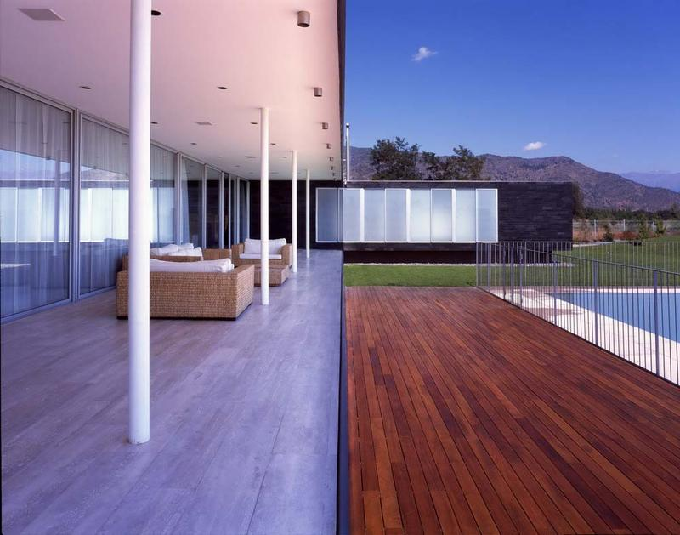

Part B
You are to make 2 sketches and a 'good' 2-point perspective drawing of this house interior. Try to focus on shading on the white wall in the top right corner. The best place to start is to divide the sheet into quarters and work out proportions. KEY: In the good copy 2 point perspective you are to change the bed with a different type of bed of another type taken from an image search of Google.
http://en.wikipedia.org/wiki/Bed#Types_of_beds
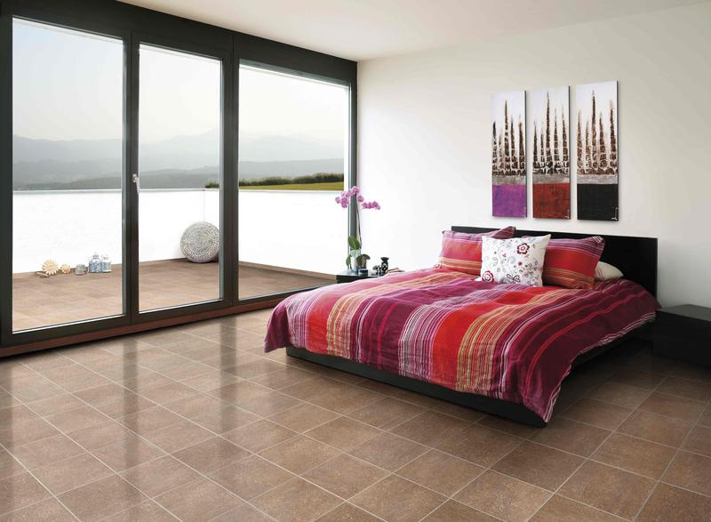
For a brief overview of 2-point drawing if you forget - follow this tutorial link.
To submit:
- Minimum of 2 sketches of each picture
- One 1-point perspective of the first picture
- One 2-point perspective drawing (including the changed bed).
- One PSD collage of the sketches and the good copy of the 1 and 2 point drawing

You will be evaluated as follows:
CATEGORY | LEVEL 1  12 13 | LEVEL 2  14 15 | LEVEL 3  16 17 | LEVEL 4  18 19 20
Sketches  (Thinking) | The sketches have many defects or are poor quality. | The sketches have some defects, but still portray the object. | Good choices in line-weights and angles that best illustrate the chosen topics. Drawings are defect-free but may contain a few unwanted features. | Superb choices in line-weights and angles that best illustrate the object. Drawings are free from distracting elements.
1 point perspective drawing  (Application) | Lines merge but with much room for improvement. | Lines generally at the VP. | Lines merge at the VP with few flaws in the drawing. | Lines merge seamlessly at the VP. There are no flaws in the drawing.
2 point perspective drawing  (Application) | Lines generally merge towards the VPs. There are multiple flaws in the drawing. | Lines merge at both VPs. There are flaws in the drawing. | Lines merge well at both VPs. There are generally no flaws in the drawing. | Lines merge seamlessly at both VPs. There are no flaws in the drawing.
Bed replacement  (Thinking) | The bed has been replaced, but the style doesn't reflect the type of room design at all. | The bed has been replaced with a type of bed that doesn't quite integrate into the room. | The bed has generally been replaced with a type of bed that integrates into the room. | The bed has been replaced with a type of bed that flawlessly integrates into the room.
Use of Time | Used time poorly (as shown by observation by teacher and/or documentation of progress in journal) in spite of several reminders to do so. | Used time well (as shown by observation by teacher and documentation of progress in journal), but required reminders on one or more occasions to do so. | Used time well during most class periods (as shown by observation by teacher, and documentation of progress in journal) with no reminders. | Used time well during each class period (as shown by observation by teacher, and documentation of progress in journal) with no reminders.
File type and size  (Knowledge) | Only a few of the requirements have been met. | Many present. Some important components missing. | Generally all elements are present. | All elements are present.

